EV CHARGING STATION MANAGEMENT SYSTEM

23CS54C – MODERN WEB TECHNOLOGIES

Submitted by

SHANMUGAPRIYAN P-2403957610421007

In partial fulfillment for the award of the degree of
BACHELOR OF ENGINEERING/TECHNOLOGY
in
COMPUTER SCIENCE AND ENGINEERING/ INFORMATION TECHNOLOGY

NATIONAL ENGINEERING COLLEGE
(An Autonomous Institution affiliated to Anna University, Chennai)
K.R NAGAR, KOVILPATTI - 628503 OCTOBER - 2026
NATIONAL ENGINEERING COLLEGE
(An Autonomous Institution affiliated to Anna University, Chennai) K.R.NAGAR, KOVILPATTI - 628503

BONAFIDE CERTIFICATE

This is to certify that this project report, “EV CHARGING STATION MANAGEMENT SYSTEM”, is the bonafide work of SHANMUGAPRIYAN P(24104007)who carried out the project work under my supervision.

Course Instructor/Guide

Submitted to the 23CS54C – MODERN WEB TECHNOLOGIES Viva-Voce examination held at National Engineering College, K.R.Nagar, Kovilpatti on

Internal Examiner Co Examiner

TABLE OF CONTENTS

CH NO | TITLE | PAGE NO
1 | INTRODUCTION | 3
2 | OBJECTIVES | 4
3 | DESCRIPTION | 5
4 | CLASS DIAGRAM | 6
5 | TABLE STRUCTURES | 7
6 | ER DIAGRAM | 11
7 | TECH STACK | 12
8 | MODULES | 13
9 | CONCLUSION | 55

CHAPTER 1

INTRODUCTION

The EV Charging Station Management System is a web-based application developed to manage and organize electric vehicle charging services digitally. It provides a platform for EV users, charging station owners, and administrators to manage charging-related activities efficiently. The system reduces the need for manual methods of finding charging stations, checking availability, and booking charging slots. It provides separate access and features for different users based on their roles.
The Admin can manage users, charging stations, station owners, bookings, and other system activities. The EV Station Owner can manage station details, charging slots, availability, and bookings through a dedicated dashboard. The EV User can register and log in to the system, add vehicle details, locate charging stations, check availability, book charging slots, make payments, and view booking history. The system also provides map-based location services to help users find suitable charging stations easily.
The system helps reduce waiting time, avoid booking conflicts, and maintain accurate charging records. It improves transparency by providing role-based access and separate dashboards for users, station owners, and administrators. The user-friendly interface makes the system easy to use and manage. By integrating charging station management, vehicle details, slot booking, location services, payments, and monitoring features into a single platform, the proposed system provides an organized and efficient solution for managing electric vehicle charging services.

CHAPTER 2

OBJECTIVES

- To provide a centralized platform for managing electric vehicle charging stations and charging services efficiently.
- To provide secure role-based login and access for EV Users, Station Owners, and Administrators.
- To allow EV Users to register their vehicles, locate charging stations, and check charging slot availability.
- To enable users to book charging slots based on station availability and receive booking confirmation.
- To allow Station Owners to manage station details, charging slots, availability, and customer bookings.
- To provide map-based location services for finding nearby EV charging stations easily.
- To integrate online payment functionality for completing charging slot bookings securely.
- To provide real-time updates for booking status, slot availability, and charging-related activities.
- To maintain accurate digital records of users, vehicles, stations, bookings, payments, and charging activities.
- To provide search and filtering features for quickly finding charging stations and booking information.
- To provide an easy-to-use and responsive interface for smooth navigation across all modules.
- To provide an administrative dashboard for monitoring users, stations, bookings, payments, and overall system activities.

CHAPTER 3

DESCRIPTION

The EV Charging Station Management System is a web-based application designed to manage electric vehicle charging stations, users, station owners, and charging bookings efficiently. The system provides different types of users, including EV User, Station Owner, and Admin, with separate dashboards and functionalities based on their roles. The Admin can manage users, charging stations, station owners, bookings, and other system activities. All important information is maintained digitally to provide easy access and efficient management.
The EV User can register and log in to the system, add vehicle details, search for charging stations, view station availability, and book charging slots. The system also provides map-based location services to help users find suitable charging stations. Users can make online payments, view booking history, check booking status, and receive updates related to their charging reservations. The Station Owner can manage charging station information, charging slots, availability, and customer bookings through a dedicated dashboard.
The system helps reduce manual work, waiting time, and booking conflicts by providing a centralized platform for charging station management. It maintains organized records of users, vehicles, stations, bookings, and payments. The system also improves transparency between users, station owners, and administrators through real-time updates and role-based access. Overall, the project provides a convenient, organized, and efficient solution for managing electric vehicle charging services.

CHAPTER 4

CLASS DIAGRAM

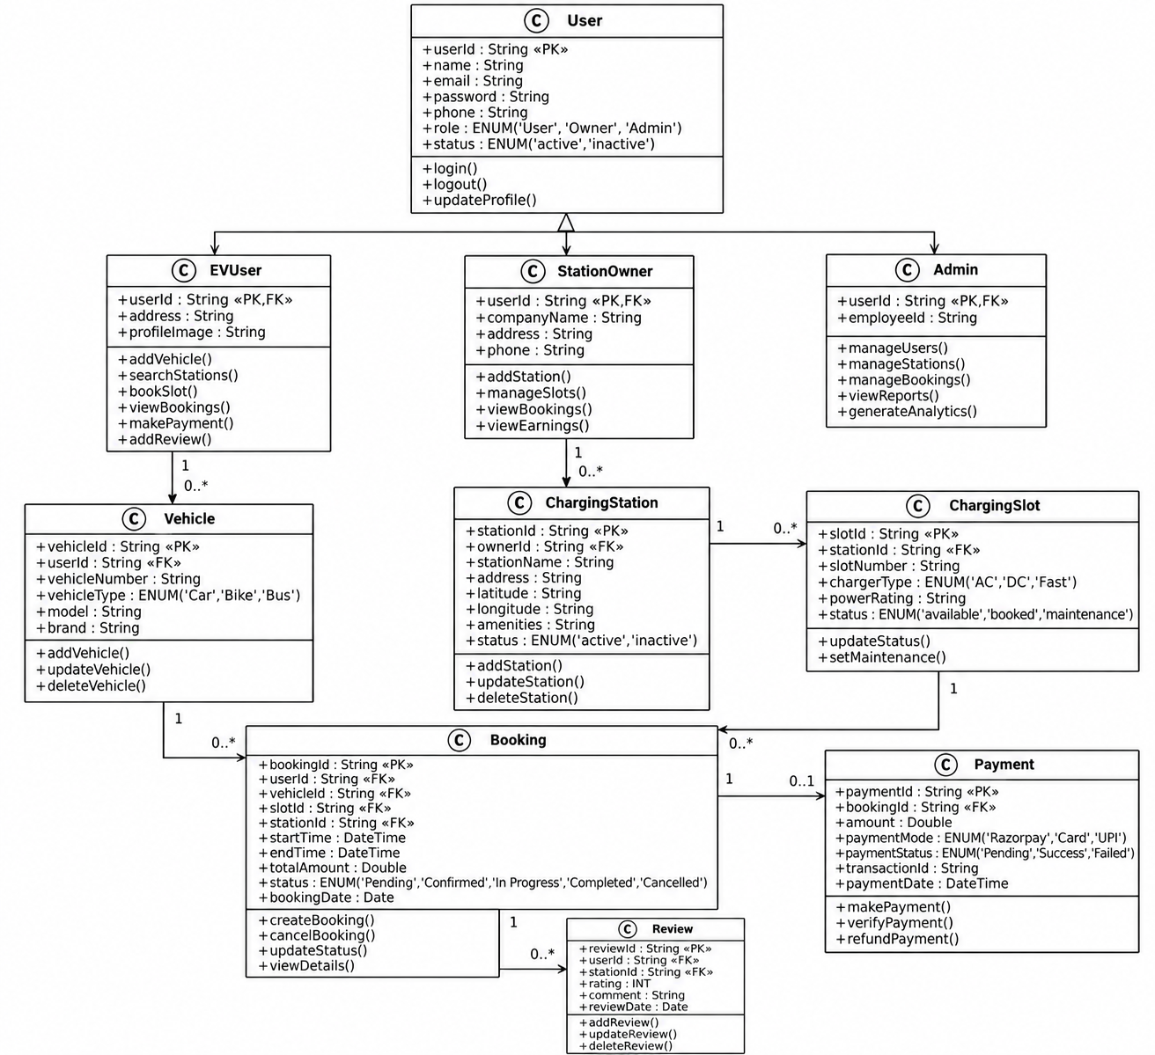

CHAPTER 5

TABLE STRUCTURES

Users
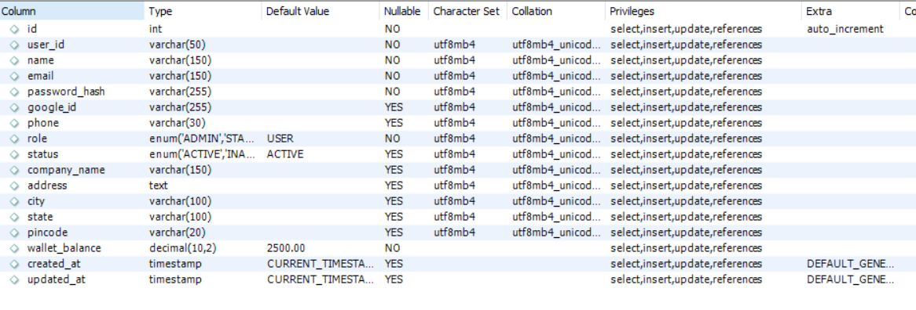

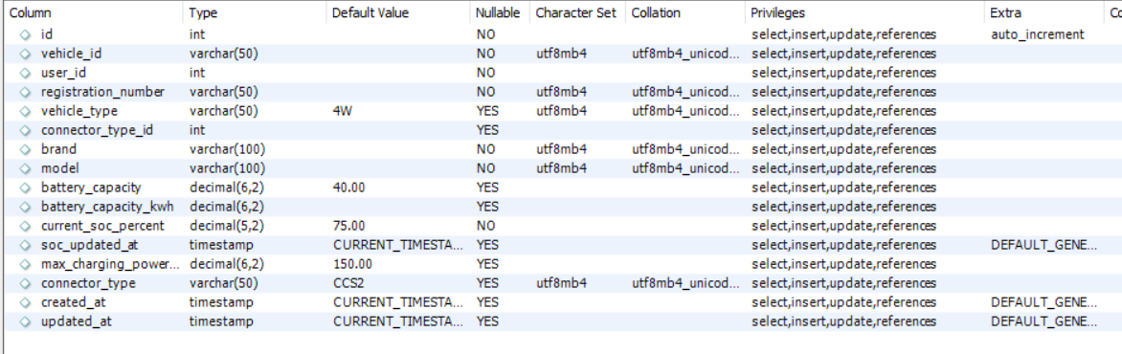
Vehicle details

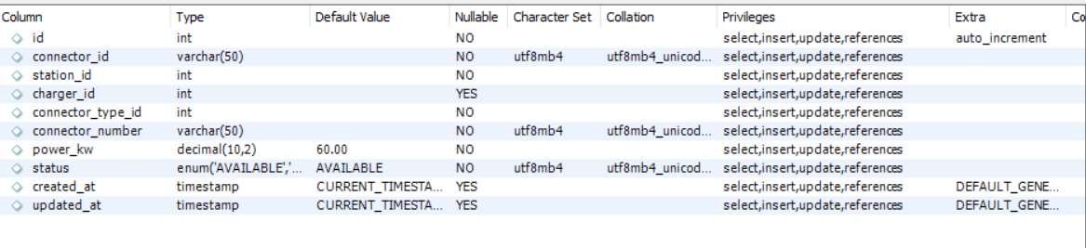
Connectors

Owner details
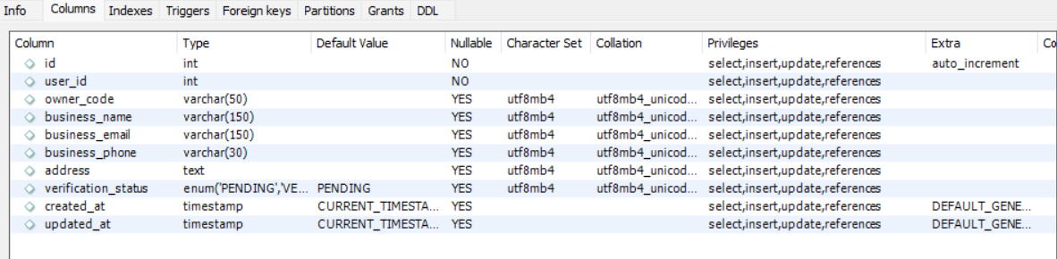

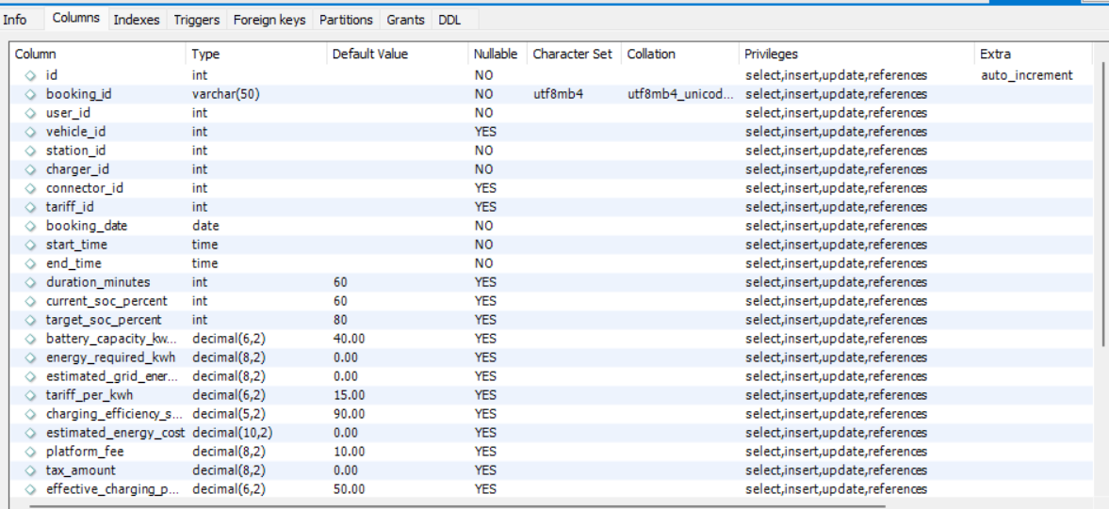
Bookings

Payments

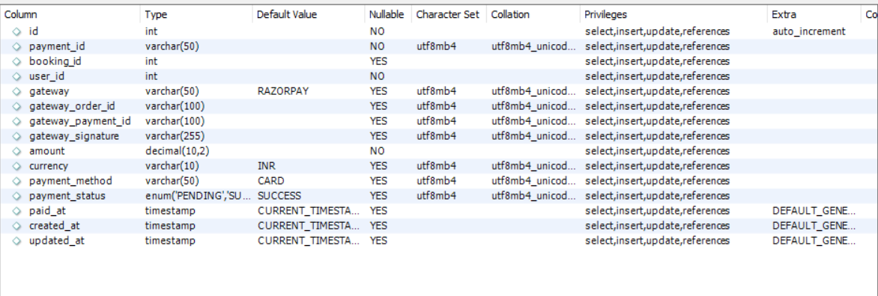

Tariffs
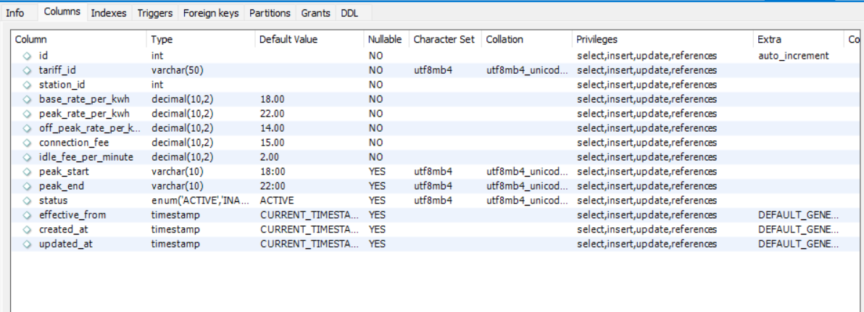

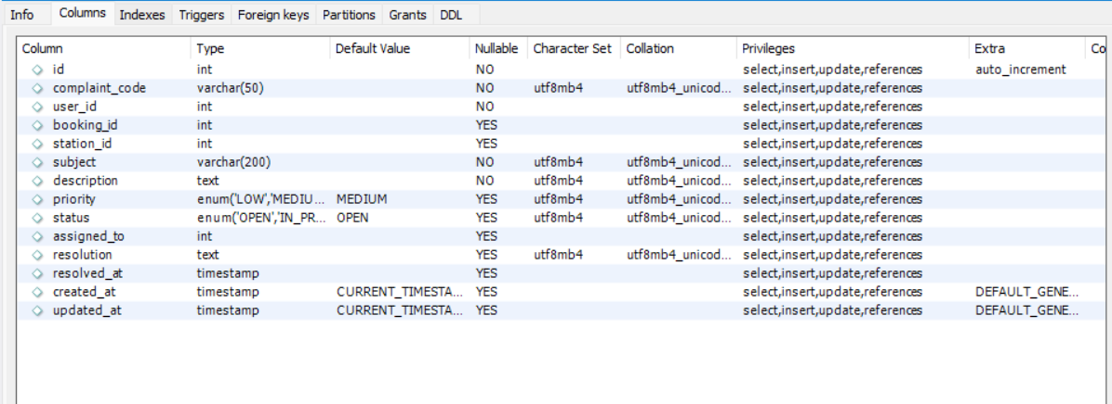
Complaints

Stations
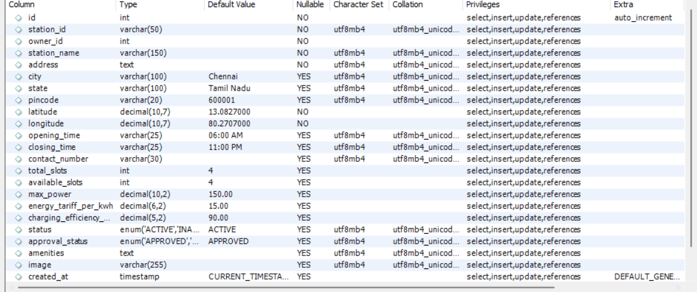

CHAPTER 6

ER DIAGRAM

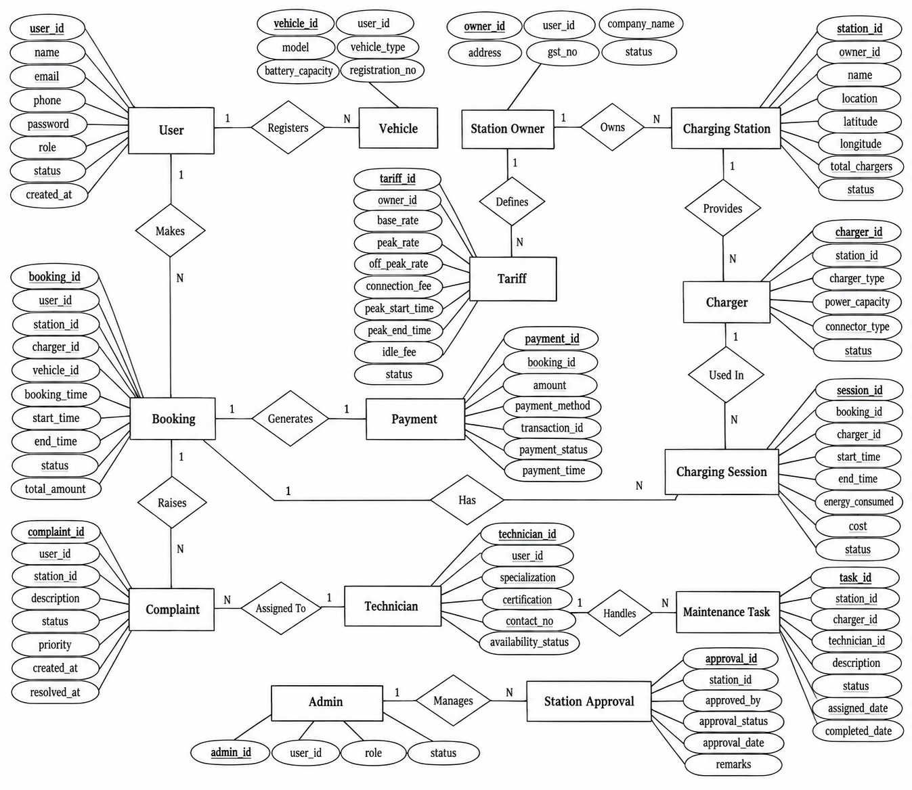

CHAPTER 7 TECH STACK
Frontend Technologies: React.js, Vite, Tailwind CSS, Lucide React, React Icons, Framer Motion, Leaflet / React-Leaflet, Axios, Socket.io Client
Backend Technologies: Node.js, Express.js, Socket.io, Nodemailer, Razorpay SDK, JSON Web Tokens (JWT), Bcrypt.js, Helmet, Dotenv
Middleware: JWT Authentication Middleware, Role-Based Access Control (RBAC) Middleware, CORS Middleware, Express Rate Limiting Middleware, Helmet Security Headers Middleware, Express JSON & URL-Encoded Body Parser
Database: MySQL using mysql2/promise with Connection Pooling and ACID Transactions
Approach: Parameterized SQL Queries with Connection Pooling, Atomic Database Transactions, Async/Await Programming, RESTful API Design, Stateless JWT Authentication, Multi-Method Authentication using OTP, Password and Google OAuth, Real-Time Bidirectional WebSocket Communication, Modular Architecture

Architecture: MVC (Model-View-Controller)
- Models: Relational MySQL schema tables representing system entities such as Users, Vehicles, Stations, Chargers, Connector Types, Bookings, Payments, Wallets, Wallet Transactions, Charging Sessions, Tariffs, Complaints, Maintenance, Audit Logs, and Reviews.
- Views: React.js Single-Page Application components handling role-based dashboards for Customer, Station Owner, Admin, Technician, and Security, along with live EV charging telemetry widgets, interactive maps, booking interfaces, and payment checkout interfaces.
- Controllers: Express.js route handlers managing authentication, booking, payment, station, vehicle, wallet, owner, and technician operations, including business logic, charging calculations, payment verification, slot conflict prevention, and JSON API responses.

CHAPTER 8
MODULES
8.0 DESIGN APPROACH
Chapter 8 documents the implemented modules of the EV Charging Station Management System using a common technical structure. Each major module is described through its purpose, functional requirements, non-functional requirements, technology choices, design-stage estimation, low-level architecture, request flow, API design, database design, and implemented interface screenshots.
The architecture descriptions and API tables in this chapter are derived from the supplied backend and frontend source files. Database descriptions are based on the supplied MySQL schema and migration scripts. Estimates are explicitly design-stage estimates and are not measured production benchmarks.
Section | Purpose
Purpose & Scope | Defines what the module covers and its role in the overall EV charging system.
Functional Requirements | Lists the principal operations supported by the implemented module.
Non-Functional Requirements | Describes security, reliability, usability, performance and maintainability expectations.
Tech Stack | Shows the technology or implementation file used and why it fits the module.
Back-of-the-Envelope Estimation | Provides compact design-stage capacity estimates and identifies them as estimates.
Low-Level Architecture | Shows the module-specific React, REST, middleware, controller, service and MySQL layers.
Request Flow | Describes how a user action travels through the implemented application layers.
API Design | Lists representative implemented endpoints using a six-column technical table.
DB Design | Identifies the principal database tables used by the module without duplicating Chapter 5.
Screenshots / Figures | Shows the existing implemented application screens and project-structure figures.

Common Platform Baseline
The supplied implementation uses React 19 with React Router on the frontend, Node.js and Express.js on the backend, MySQL through mysql2, JWT-based authentication, role-based middleware, Socket.IO for real-time communication, Razorpay for payment processing, Leaflet/React-Leaflet for maps, and reusable React services and components. The backend also configures security middleware such as Helmet, CORS and rate limiting.
The supplied source tree contains 18 backend route files, 15 controller files, 25 frontend service files, and a MySQL schema containing 16 core CREATE TABLE definitions. These counts describe the supplied implementation at the time of report preparation.
8.1 FOLDER STRUCTURE AND SYSTEM ARCHITECTURE
Purpose & Scope
This module documents the implemented project organization and the separation between the React client, Express API server, service layer, authentication middleware and MySQL database. It provides the structural foundation used by the functional modules.
Functional Requirements
- Organize frontend pages, reusable components, contexts, layouts and API services.
- Organize backend routes, controllers, services, middleware, database scripts and utilities.
- Provide REST endpoints through Express and connect them to MySQL using mysql2.
- Support role-based dashboards for customers, station owners, administrators, technicians and security users.
- Support real-time communication through Socket.IO for charging and operational updates.
Non-Functional Requirements
- Maintainability through separation of routes, controllers and services.
- Security through JWT authentication, role authorization, Helmet, CORS and rate limiting.
- Reliability through MySQL connection pooling, parameterized queries and transactional operations where required.
- Scalability through modular APIs and reusable React components.
Tech Stack
Concern | Choice | Why it fits this module | Implementation / files
Frontend | React.js + React Router | Provides the single-page interface and role-based navigation. | src/pages, src/components, src/layouts, App.jsx
API | Node.js + Express.js | Provides modular REST endpoints for system operations. | server.js, routes/, controllers/
Database | MySQL + mysql2 | Stores relational charging, booking, user and payment data. | config/db.js, database/schema.sql
Security / Realtime | JWT + Socket.IO | Protects APIs and delivers live charging/status updates. | middleware/, services/socketService.js

Back-of-the-Envelope Estimation
The following values are design-stage estimates for capacity planning. They are not measured production benchmarks.
Parameter | Estimated value | Basis / interpretation
Frontend modules | 50+ pages/components | Design-scale inventory from the supplied source tree
Backend route files | 18 | Counted from backend/routes/*.js in the supplied source
Database tables | 16 core tables | CREATE TABLE definitions in schema.sql
Realtime channels | Charging and operational events | Socket.IO is initialized by server.js

Low-Level Architecture
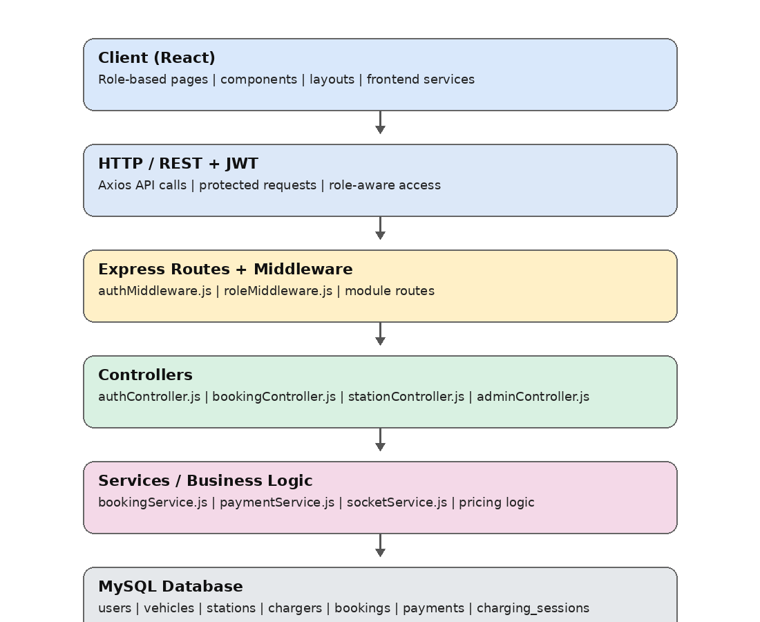

Low-Level Architecture – 8.1.A Folder Structure And System Architecture

Request Flow
- React page or component
- Axios request to /api endpoint
- Express route and middleware
- Controller executes module logic
- Service/database operation
- JSON response or Socket.IO update
API Design
The following representative routes are taken from the supplied Express route files and their server-level /api mounting. Authorization labels summarize the route or middleware context present in the source.
Method | Endpoint | Auth / Role | Request / Parameters | Response | Purpose / Contract
GET | /api/health | Public | None | JSON health response | Check server availability
POST | /api/auth/login | Public | email / password or ID | JWT/session response | Authenticate a user
GET | /api/stations | Optional auth | Query filters | Station list | Retrieve charging stations
GET | /api/bookings/my | User | Authenticated user | Booking list | Retrieve current user's bookings
GET | /api/charging/active | User | Authenticated user | Active session | Retrieve active charging session
GET | /api/admin/stats | ADMIN | JWT + ADMIN role | Dashboard statistics | Retrieve platform statistics

DB Design
Only the principal tables used by this module are listed below. Complete table structures and relationships are retained in Chapters 5 and 6.
Table | Key fields | Relationship | Purpose
users | id, user_id, role, status | Primary identity for roles | Authentication and access control
stations | station_id, owner_id, location, status | Station owned by an owner | Charging infrastructure
bookings | booking_id, user_id, vehicle_id, station_id | Links user, vehicle and charger | Reservation records
charging_sessions | session_id, booking_id, charger_id, energy_kwh | Links active/completed sessions | Charging telemetry and billing
Screenshots / Figures

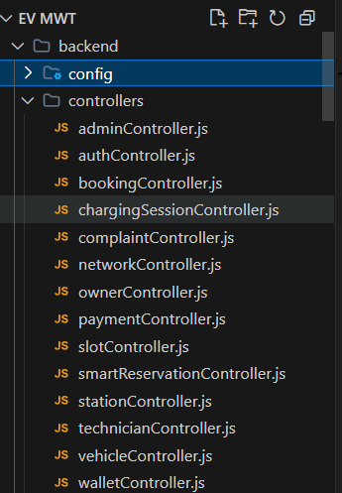

Fig 8.1– Backend Folder Structure – Overall organization of backend files and directories showing modular architecture.
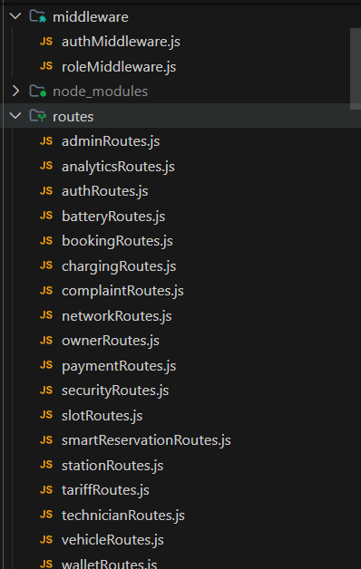
Fig 8.2 – Backend Routes – Defined RESTful API routes connecting client requests to backend controllers.
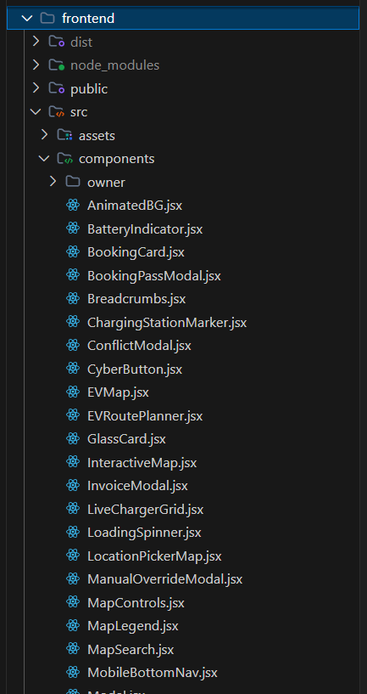
Fig 8.3– Frontend Folder Structure – Layout of React-based frontend directories with components and pages.
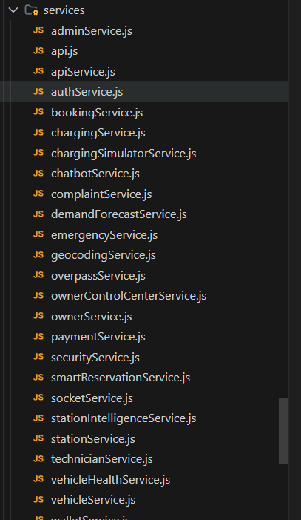
Fig 8.4– Service Pages
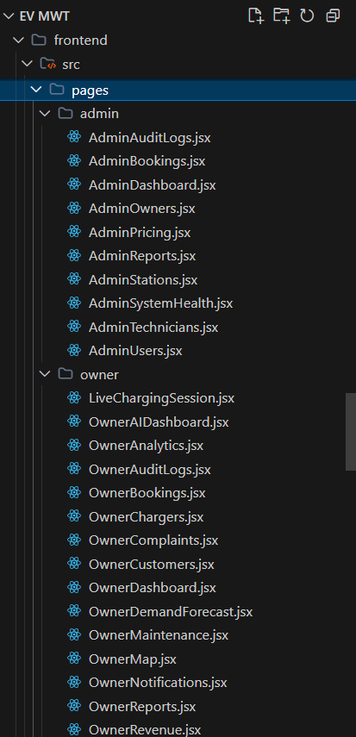

Fig 8.5– Owner and Admin Pages – Interfaces designed separately for Owner and Admin
8.2 AUTHENTICATION AND ACCESS CONTROL
Purpose & Scope
The Authentication and Access Control module provides the common entry point for all roles. It supports registration, password/ID login, OTP verification, Google authentication, profile access and role-based authorization.
Functional Requirements
- Register customer and station-owner accounts.
- Authenticate users using password/ID, email OTP or Google sign-in.
- Issue and validate JWT-based authenticated sessions.
- Retrieve and update the authenticated user profile.
- Apply role normalization and authorization for protected administrative and owner resources.
Non-Functional Requirements
- Prevent unauthorized access to protected endpoints.
- Apply rate limiting to sensitive authentication operations.
- Protect passwords using bcrypt-based hashing in the authentication implementation.
- Provide clear authentication failure responses and session expiry handling.

Back-of-the-Envelope Estimation
The following values are design-stage estimates for capacity planning. They are not measured production benchmarks.
Parameter | Estimated value | Basis / interpretation
Registered users | 100–1,000 | Design-stage capacity estimate
Login requests/day | 100–500 | Depends on project usage
OTP operations/day | 50–300 | Expected authentication activity
Target response | < 2 seconds | Design target, not measured production result

Request Flow
- Login/Register page
- POST /api/auth request
- Authentication middleware for protected routes
- authController.js
- MySQL users lookup / credential verification
- JWT response and role-based dashboard redirect

API Design
The following representative routes are taken from the supplied Express route files and their server-level /api mounting. Authorization labels summarize the route or middleware context present in the source.
Method | Endpoint | Auth / Role | Request / Parameters | Response | Purpose / Contract
POST | /api/auth/register | Public | Registration fields | User ID / status | Create user account
POST | /api/auth/login | Public | Credentials | JWT + user role | Authenticate user
POST | /api/auth/send-otp | Public | Email | OTP status | Send login OTP
POST | /api/auth/verify-otp | Public | Email + OTP | Authentication response | Verify OTP
POST | /api/auth/google | Public | Google credential | Authentication response | Google sign-in
GET | /api/auth/me | Authenticated | JWT | Current profile | Retrieve logged-in user

DB Design
Only the principal tables used by this module are listed below. Complete table structures and relationships are retained in Chapters 5 and 6.
Table | Key fields | Relationship | Purpose
users | user_id, email, password_hash, role, status | Role and identity record | Stores account and access data
login_activity | User/login event fields | Associated with user activity | Tracks authentication activity
notifications | user_id, type, message | User notification relation | Supports system messages
audit_logs | user_id, action, entity | User/action relationship | Records security-sensitive operations

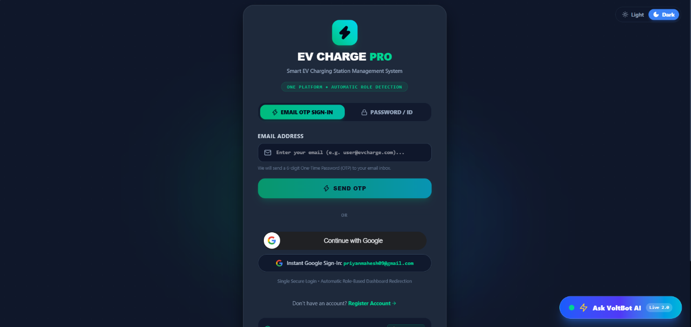
Screenshots / Figures

Fig 8.6– EV CHARGE PRO LOGIN PAGE-SECURE AUTHENTICATION WITH OTP,PASSWORD AND GOOGLE SIGN-IN
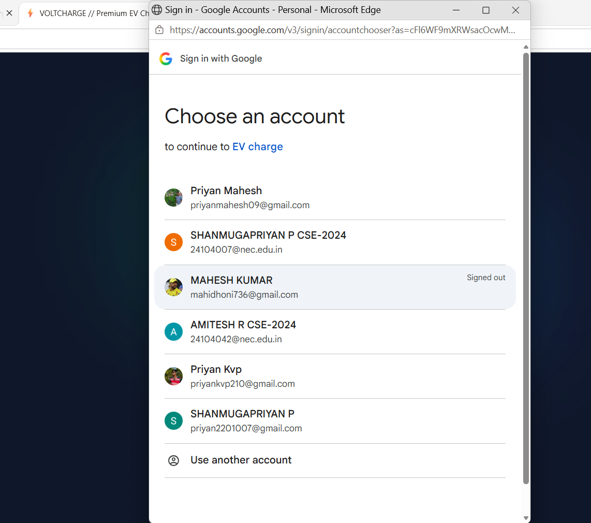
The login page allows registered users to securely access the EV Charging Station Management System using Email OTP, password/ID, or Google Sign-In. It provides a simple and user-friendly interface for authentication. After successful login, users are redirected to their respective dashboards based on their roles.

Fig. 8.7 – Google OAuth Account Selection for User Authentication
The Google Sign-In feature allows users to authenticate using their existing Google accounts without manually entering their credentials. It provides a convenient and secure login process for accessing the EV Charging Station Management System.

8.3 EV USER AND VEHICLE MANAGEMENT
Purpose & Scope
This module manages the customer profile and registered electric vehicles used during charging. Vehicle data includes identification, connector type, battery capacity and current state of charge, allowing later booking and charging calculations to use vehicle-specific information.
Functional Requirements
- Register, view, update and delete vehicles.
- Store registration number, brand, model, vehicle type and connector type.
- Store battery capacity and current state of charge.
- Maintain SOC history and vehicle health information where supported.
- Present customer dashboard information and vehicle-related actions.
Non-Functional Requirements
- Validate vehicle input before database insertion or update.
- Keep vehicle records associated with the authenticated user.
- Provide responsive dashboard and vehicle interfaces.
- Maintain consistent SOC information for charging calculations.
Back-of-the-Envelope Estimation
The following values are design-stage estimates for capacity planning. They are not measured production benchmarks.
Parameter | Estimated value | Basis / interpretation
Registered vehicles | 100–1,000 | Design-stage capacity estimate
Vehicle API requests/day | 100–500 | Depends on user activity
SOC updates/user | 1–10 | Expected session/vehicle updates
Target response | < 2 seconds | Design target

Request Flow
- Customer dashboard / vehicle page
- vehicleService.js request
- vehicleRoutes.js / batteryRoutes.js
- vehicleController.js
- Vehicle/battery service logic
- MySQL vehicles and battery_details

API Design
The following representative routes are taken from the supplied Express route files and their server-level /api mounting. Authorization labels summarize the route or middleware context present in the source.
Method | Endpoint | Auth / Role | Request / Parameters | Response | Purpose / Contract
GET | /api/vehicles/my | Authenticated | JWT | Vehicle list | Retrieve current user's vehicles
POST | /api/vehicles | Authenticated | Vehicle details | Created vehicle | Register a vehicle
PUT | /api/vehicles/:id | Authenticated | Vehicle updates | Updated vehicle | Update vehicle information
DELETE | /api/vehicles/:id | Authenticated | Vehicle ID | Deletion status | Remove a vehicle
POST | /api/vehicles/:id/soc | Authenticated | SOC value | Updated SOC | Update battery state of charge
GET | /api/vehicles/:id/soc-history | Authenticated | Vehicle ID | SOC history | Retrieve SOC history

DB Design
Only the principal tables used by this module are listed below. Complete table structures and relationships are retained in Chapters 5 and 6.
Table | Key fields | Relationship | Purpose
vehicles | vehicle_id, user_id, registration_number, battery_capacity | References users | Stores EV specifications
battery_details | vehicle_id, current_percentage, health_percentage | References vehicles | Stores battery status
users | id, user_id, name, email | Parent identity | Associates vehicles with customers
charging_sessions | vehicle_id, session_id, energy_kwh | References vehicle | Uses vehicle during charging

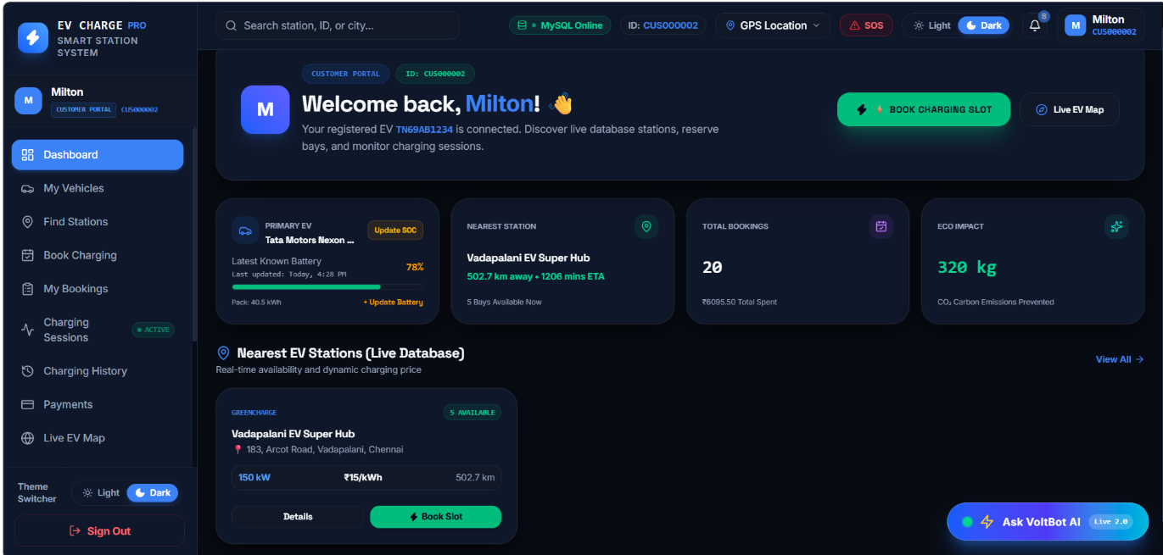
Screenshots / Figures

Fig 8.8– Customer Dashboard – Displaying EV details, station availability, and booking information.
The customer dashboard provides an overview of the registered electric vehicle, nearest charging stations, total bookings, and environmental impact. It allows users to access vehicle details, find stations, book charging slots, and monitor charging sessions. The dashboard also displays live station availability and estimated charging prices for convenient planning.
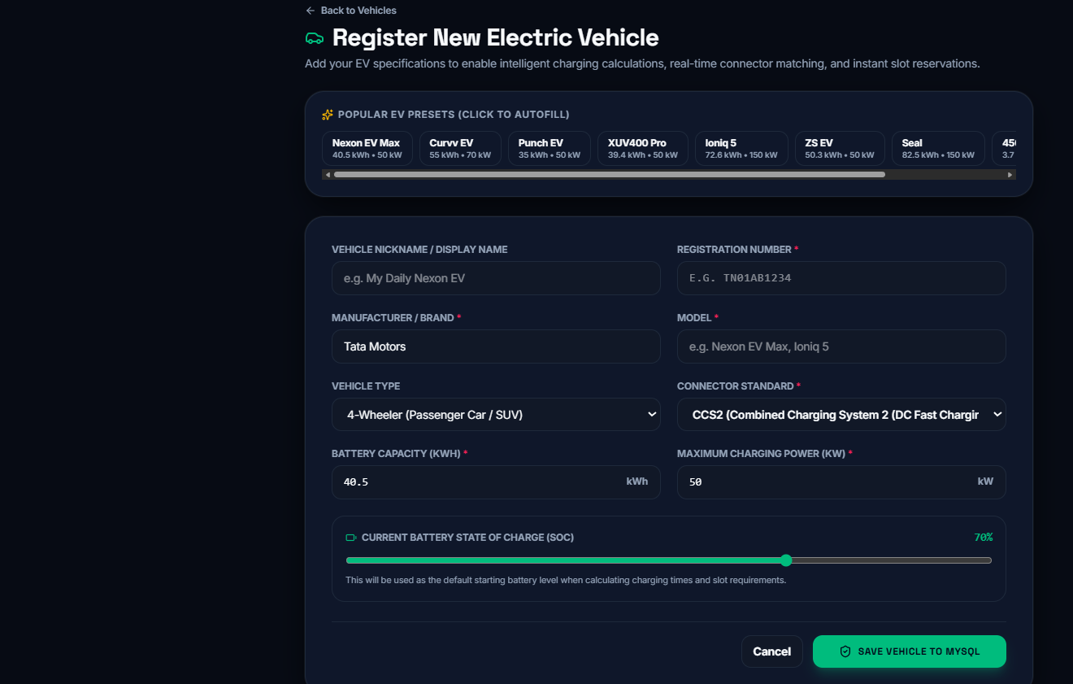

Fig 8.9 – Register New Electric Vehicle – Entering vehicle specifications and battery information.
The vehicle registration page allows users to enter their vehicle details, including registration number, manufacturer, model, vehicle type, connector standard, and battery capacity.
8.4 CHARGING STATION DISCOVERY AND MAP
Purpose & Scope
The Charging Station Discovery module helps users locate available EV charging stations, inspect station information, view connectors and power status, and navigate to a selected station through an interactive map interface.
Functional Requirements
- Display charging stations on an interactive map.
- Search stations or cities and retrieve station details.
- Filter or inspect station availability and charger information.
- Display connector type, power, tariff and station status.
- Provide station details and directions/booking entry points.
Non-Functional Requirements
- Provide responsive map interaction.
- Keep station data synchronized with the backend where live status is available.
- Use secure APIs for owner-only station modifications.
- Handle external map/station data without blocking core database operations.

Back-of-the-Envelope Estimation
The following values are design-stage estimates for capacity planning. They are not measured production benchmarks.
Parameter | Estimated value | Basis / interpretation
Stations displayed | 50–500 | Design-stage map dataset estimate
Map queries/day | 100–1,000 | Depends on user traffic
Marker response | < 2 seconds target | Design target
External lookup | As required | Used only for configured external sources

Low-Level Architecture – 8.4.A Charging Station Discovery And Map
Request Flow
- EVMapPage / FindStations
- stationService.js
- stationRoutes.js / networkRoutes.js
- stationController.js / networkController.js
- MySQL and configured external station sources
- Station markers and details returned to React

API Design
The following representative routes are taken from the supplied Express route files and their server-level /api mounting. Authorization labels summarize the route or middleware context present in the source.
Method | Endpoint | Auth / Role | Request / Parameters | Response | Purpose / Contract
GET | /api/stations/approved | Public/optional auth | Filters | Approved station list | Retrieve approved stations
GET | /api/stations/map | Public | Map/filter parameters | Map station data | Retrieve map-ready stations
GET | /api/stations/:stationId/connectors | Optional auth | Station ID | Connector list | Retrieve station connectors
GET | /api/stations/:id/power-status | Authenticated/role-dependent | Station ID | Power/status data | Retrieve station power status
GET | /api/stations/:id | Public/optional | Station ID | Station details | Retrieve station details
GET | /api/stations/:id/price-quote | Optional auth | Station ID + charging inputs | Price quote | Estimate station charging cost

DB Design
Only the principal tables used by this module are listed below. Complete table structures and relationships are retained in Chapters 5 and 6.
Table | Key fields | Relationship | Purpose
stations | station_id, station_name, address, latitude, longitude, status | Owner/station relationship | Stores station location and status
chargers | charger_id, station_id, charger_type, power_kw, status | References station | Stores charger availability
charger_connectors | connector_id, charger_id, connector_type, status | References charger | Stores connector information
tariffs | tariff_id, station_id, base/peak/off-peak rates | References station | Supports displayed pricing
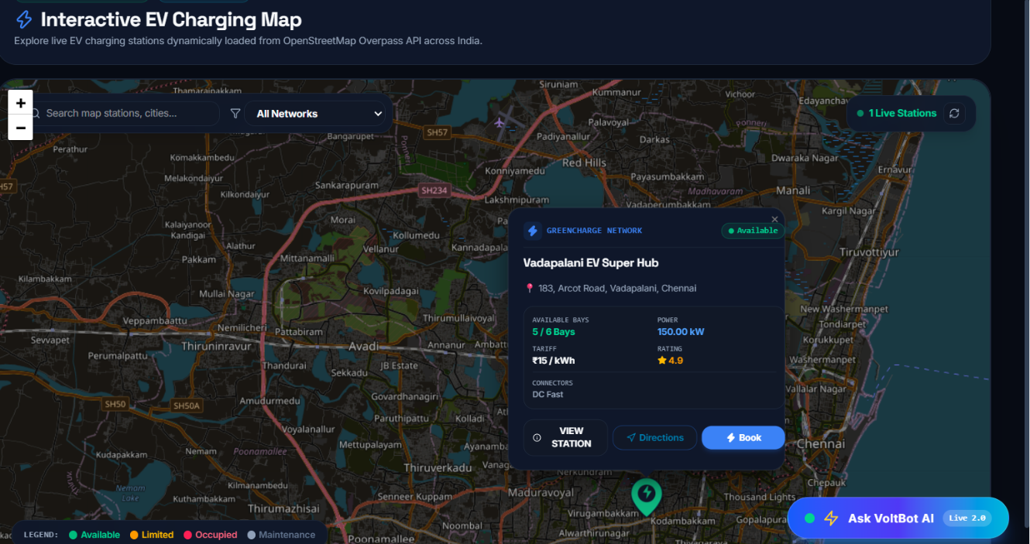
Screenshots / Figures

Fig 8.10– Interactive EV Charging Map – Displaying charging stations, availability, and booking options.
The interactive EV charging map displays nearby charging stations with their real-time availability, network, charging power, tariff, connector type, and user ratings. Users can search for stations, view station details, get directions, and book an available charging slot directly from the map.
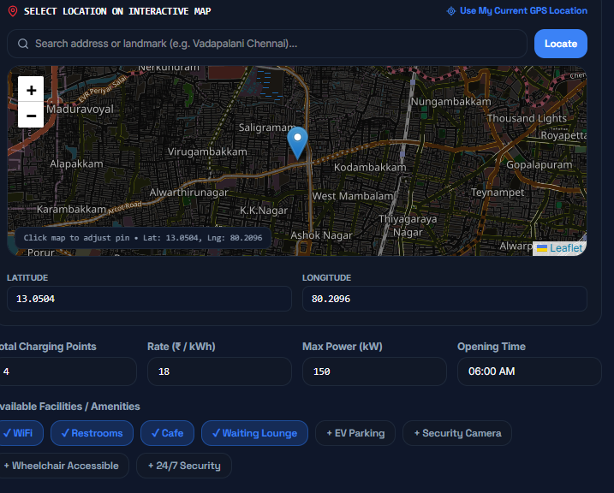
Fig. 8.11 – EV Charging Station Location Selection on Interactive Map
The location selection interface allows users to choose a charging station location by searching for an address, selecting a map point, or using their current GPS location. It also captures latitude, longitude, charging-point capacity, tariff, maximum power, opening time, and available amenities.
8.5 CHARGING RESERVATION AND BOOKING
Purpose & Scope
The reservation and booking module converts station and vehicle selections into a scheduled charging reservation. It checks slot or connector availability, calculates the reservation estimate, prevents conflicting bookings, and maintains booking history.
Functional Requirements
- Check station, charger and connector availability.
- Select a vehicle, target SOC, date and charging slot.
- Create, update, cancel and retrieve bookings.
- Provide booking summary and payment amount before confirmation.
- Support check-in and booking status changes.
Non-Functional Requirements
- Prevent overlapping reservations through availability and conflict checks.
- Maintain transactional consistency for booking-related data.
- Provide clear status information for upcoming and completed bookings.
- Protect booking operations using authenticated user context.

Back-of-the-Envelope Estimation
The following values are design-stage estimates for capacity planning. They are not measured production benchmarks.
Parameter | Estimated value | Basis / interpretation
Bookings/day | 100–500 | Design-stage usage estimate
Availability checks/day | 200–1,000 | Multiple checks may precede one booking
Concurrent booking users | 20–100 | Design-stage estimate
Target booking response | < 2 seconds | Design target

Low-Level Architecture – 8.5.ACharging Reservation And Booking
Request Flow
- BookSlot / SlotSelection
- bookingService.js
- bookingRoutes.js / slotRoutes.js
- bookingController.js / slotController.js
- Conflict and pricing logic
- MySQL booking/slot/charger records

API Design
The following representative routes are taken from the supplied Express route files and their server-level /api mounting. Authorization labels summarize the route or middleware context present in the source.
Method | Endpoint | Auth / Role | Request / Parameters | Response | Purpose / Contract
GET | /api/bookings/available-connectors | Optional auth | Station/time parameters | Available connectors | Find usable connectors
POST | /api/bookings/check-availability | Optional auth | Station/charger/time | Availability result | Check booking conflicts
POST | /api/bookings | Authenticated | Booking payload | Booking record | Create charging reservation
GET | /api/bookings/:bookingId | Authenticated | Booking ID | Booking details | Retrieve a booking
POST | /api/bookings/:bookingId/cancel | Authenticated | Booking ID | Cancellation status | Cancel reservation
POST | /api/bookings/check-in | Authenticated | Booking/QR details | Check-in result | Check in a confirmed booking

DB Design
Only the principal tables used by this module are listed below. Complete table structures and relationships are retained in Chapters 5 and 6.
Table | Key fields | Relationship | Purpose
bookings | booking_id, user_id, vehicle_id, station_id, charger_id, times | Links customer, EV and charger | Core reservation record
chargers | charger_id, station_id, status | References station | Provides charger availability
charger_connectors | connector_id, charger_id, status | References charger | Provides connector selection
tariffs | tariff_id, rate fields | Referenced by booking | Provides pricing snapshot

Screenshots / Figures
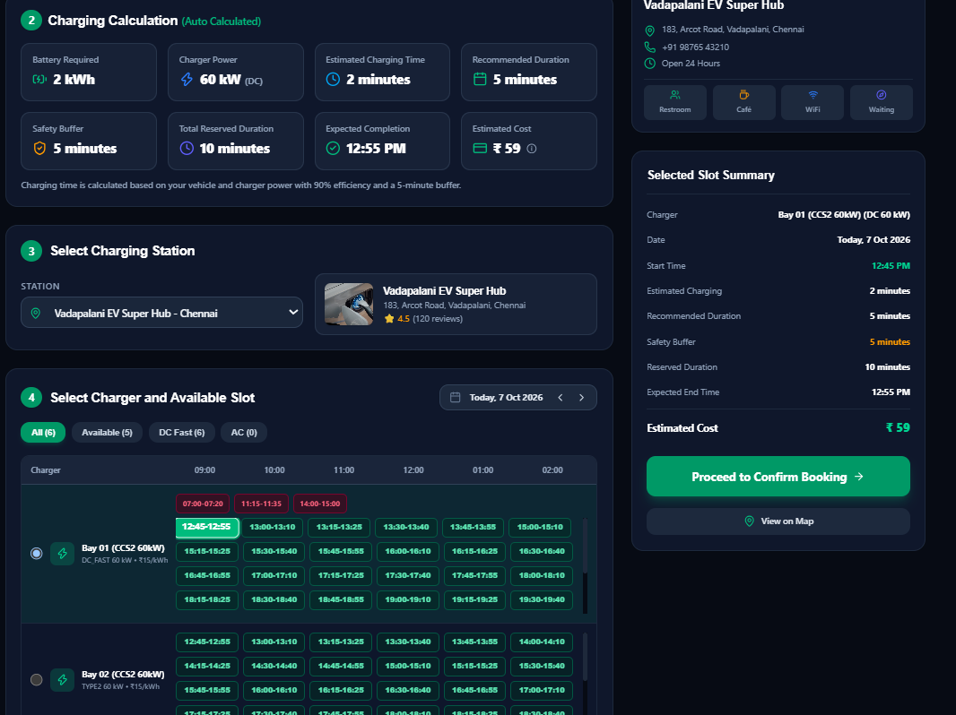

Fig 8.12– Charging Schedule – Selecting target battery level, reservation date, and available time slot.
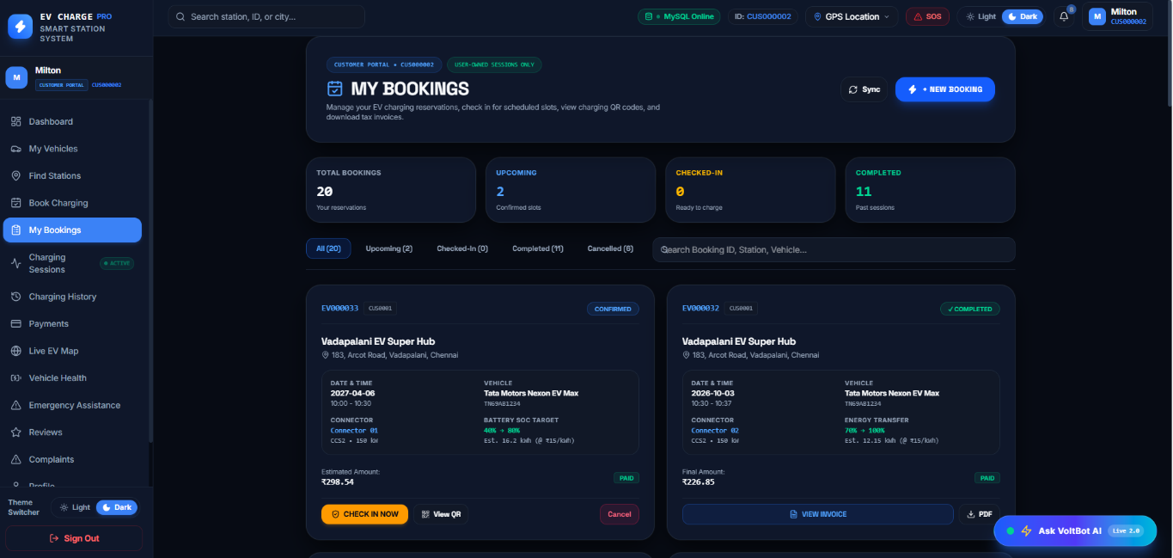
The charging booking interface automatically calculates the required battery energy, charging time, safety buffer, estimated completion time, and charging cost based on the vehicle and charger specifications. Users can select a charging station, choose an available charger and time slot, and review the booking summary before confirming the reservation.

Fig 8.13– USER Bookings – Managing EV charging reservations and booking history.
The My Bookings page allows users to view and manage their charging reservations, including upcoming, checked-in, completed, and cancelled bookings. It provides booking details, payment status, QR check-in, cancellation options, and invoice downloads for convenient reservation management.
8.6 LIVE CHARGING AND SESSION MANAGEMENT
Purpose & Scope
The Live Charging module manages an active charging session after check-in or start. It provides session start/stop operations, telemetry updates, charging history and invoice access, with Socket.IO used for real-time updates.
Functional Requirements
- Estimate charging cost and duration.
- Start and stop charging sessions.
- Update live charging telemetry.
- Display active session information and charging progress.
- Retrieve charging history and invoices.
Non-Functional Requirements
- Support near real-time status updates.
- Maintain consistent session start/end information.
- Handle charging simulator operations used by the project.
- Restrict session operations to valid authenticated context.
Back-of-the-Envelope Estimation
The following values are design-stage estimates for capacity planning. They are not measured production benchmarks.
Parameter | Estimated value | Basis / interpretation
Active sessions | 10–100 concurrent | Design-stage station-network estimate
Telemetry updates | 1–10 updates/min/session | Depends on simulator/live configuration
Session records/day | 100–500 | Design-stage estimate
Live update target | Near real-time | Socket.IO based; not a measured SLA

Request Flow
- LiveCharging page
- chargingService.js / Socket.IO client
- chargingRoutes.js
- chargingSessionController.js
- chargingService + simulator + Socket.IO
- MySQL charging_sessions and live client update

API Design
The following representative routes are taken from the supplied Express route files and their server-level /api mounting. Authorization labels summarize the route or middleware context present in the source.
Method | Endpoint | Auth / Role | Request / Parameters | Response | Purpose / Contract
POST | /api/charging/estimate | Optional auth | Vehicle/SOC/charger inputs | Energy/time/cost estimate | Estimate charging requirement
GET | /api/charging/active | Authenticated | User context | Active session | Retrieve active session
POST | /api/charging/start | Authenticated | Booking/charger data | Session ID | Start charging session
PUT | /api/charging/:sessionId/telemetry | Authenticated | Telemetry values | Updated session data | Update live telemetry
POST | /api/charging/:sessionId/stop | Authenticated | Session ID | Final session/bill data | Stop charging session
GET | /api/charging/invoices/:identifier | Authenticated | Session/booking identifier | Invoice data | Retrieve invoice

DB Design
Only the principal tables used by this module are listed below. Complete table structures and relationships are retained in Chapters 5 and 6.
Table | Key fields | Relationship | Purpose
charging_sessions | session_id, booking_id, charger_id, start/end, energy_kwh | Links booking and charger | Stores charging session
bookings | booking_id, user_id, vehicle_id, station_id | Parent reservation | Connects session to reservation
chargers | charger_id, station_id, status | Physical charger reference | Tracks charger state
vehicles | vehicle_id, user_id, battery_capacity | EV reference | Associates session with vehicle

Screenshots / Figures

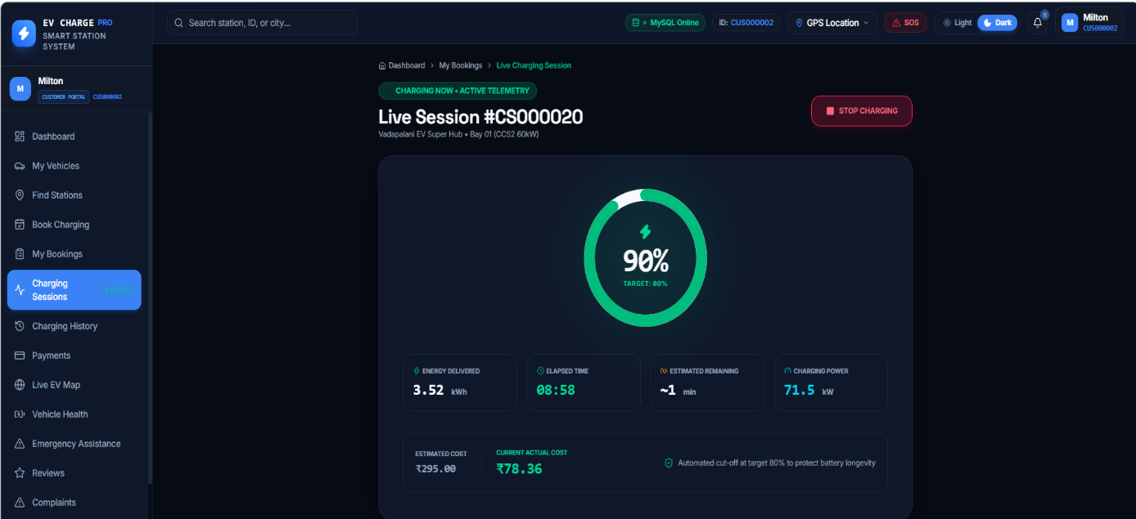
Fig 8.14 – Live Charging Session – Displaying charging progress and real-time session details.
The Live Charging Session page displays real-time charging details, including battery percentage, energy delivered, elapsed time, remaining time, and charging power. It also shows the estimated cost and current actual cost, allowing users to monitor the session and stop charging when required.
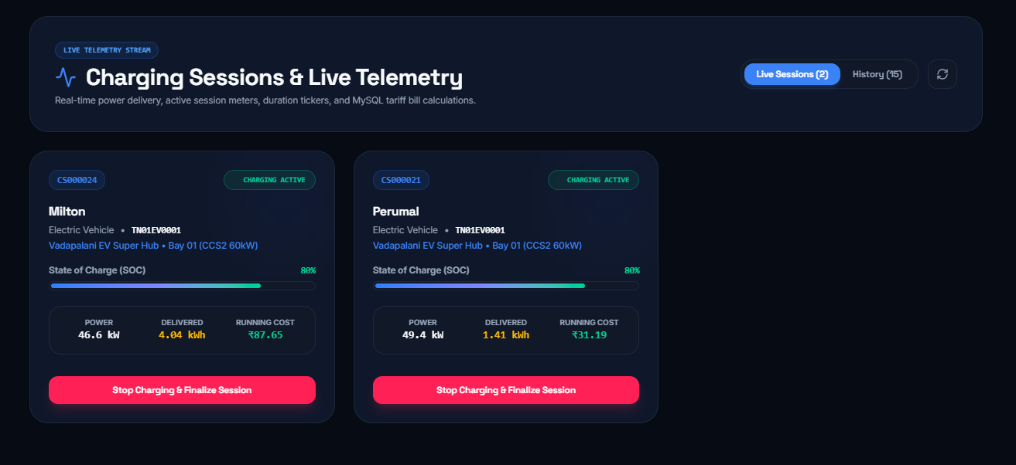
Fig. 8.15 – Charging Sessions and Live Telemetry Dashboard
The Charging Sessions and Live Telemetry page displays all active charging sessions with vehicle details, station information, battery percentage, charging power, and energy delivered. It also shows the running cost and provides an option to stop charging and finalize each session.
8.7 PAYMENT, BILLING AND WALLET
Purpose & Scope
This module completes the financial stage of a charging reservation. It creates payment orders, verifies Razorpay transactions, records payment status, supports refunds and provides wallet top-up/payment operations and billing information.
Functional Requirements
- Create Razorpay payment orders.
- Verify successful payment responses.
- Retrieve payment records and request refunds.
- Support wallet top-up and wallet payment.
- Generate or retrieve billing information for completed charging.
Non-Functional Requirements
- Do not expose payment secrets in the client application.
- Maintain payment status consistency with booking information.
- Use secure server-side verification for gateway responses.
- Maintain auditable payment and wallet transaction records.

Back-of-the-Envelope Estimation
The following values are design-stage estimates for capacity planning. They are not measured production benchmarks.
Parameter | Estimated value | Basis / interpretation
Payments/day | 50–300 | Design-stage usage estimate
Average booking value | ₹300–₹2,000 | Illustrative planning range, not measured
Payment records/day | 50–300 | Approximately one per payment attempt
Verification target | < 3 seconds | Design target excluding gateway latency

Request Flow
- PaymentPage / Razorpay modal
- paymentService.js
- paymentRoutes.js / walletRoutes.js
- paymentController.js / walletController.js
- Razorpay verification + billingService
- MySQL payments / wallet_transactions

API Design
The following representative routes are taken from the supplied Express route files and their server-level /api mounting. Authorization labels summarize the route or middleware context present in the source.
Method | Endpoint | Auth / Role | Request / Parameters | Response | Purpose / Contract
POST | /api/payments/create-order | Optional auth | Booking/amount details | Gateway order | Create payment order
POST | /api/payments/verify | Authenticated | Gateway payment identifiers | Verification status | Verify Razorpay payment
GET | /api/payments | Authenticated | User context | Payment list | Retrieve payment history
POST | /api/payments/refund | Authenticated | Payment identifier | Refund status | Request refund
POST | /api/wallet/topup | Authenticated | Amount/payment data | Wallet transaction | Add wallet balance
POST | /api/wallet/pay | Authenticated | Booking/amount | Debit transaction | Pay using wallet

DB Design
Only the principal tables used by this module are listed below. Complete table structures and relationships are retained in Chapters 5 and 6.
Table | Key fields | Relationship | Purpose
payments | payment_id, booking_id, gateway IDs, amount, status | References booking/user | Stores gateway transaction data
wallet_transactions | transaction_id, user_id, type, amount, balance_after | References user/booking | Maintains wallet ledger
bookings | booking_id, estimated_amount, payment_status | Payment association | Tracks reservation payment state
users | user_id, wallet_balance | Wallet owner | Stores current wallet balance

Screenshots / Figures
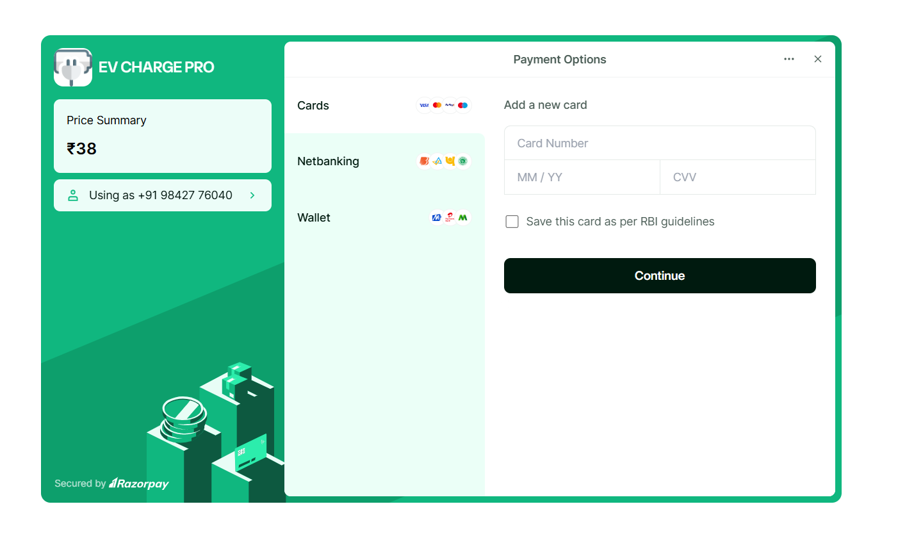
Fig 8.16 – Payment Options – Processing secure payments for EV charging bookings.
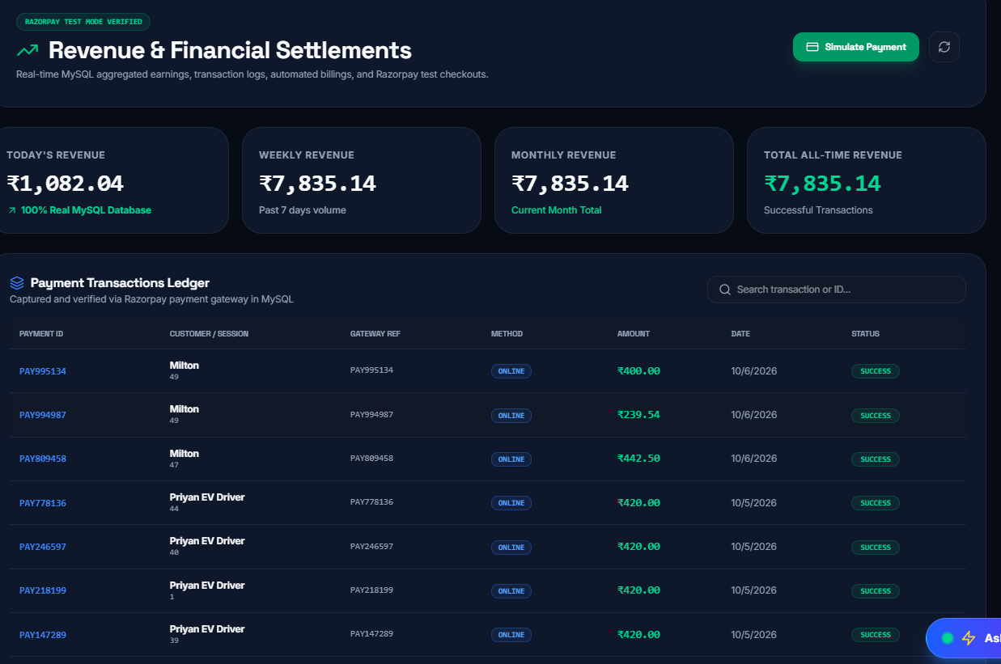
The payment interface allows users to pay charging fees using cards, net banking, or digital wallets. It displays the price summary and provides a secure payment process through Razorpay

Fig. 8.17 – Revenue and Financial Settlements Dashboard

The dashboard displays daily, weekly, monthly, and total revenue along with payment transaction records. It helps administrators monitor successful payments, transaction amounts, payment methods, and settlement activity.
8.8 STATION OWNER AND CHARGER MANAGEMENT
Purpose & Scope
This module provides station owners with tools to manage stations, chargers, live sessions, customers, maintenance information and operational performance. It also provides charger simulation and heartbeat functions used by the project.
Functional Requirements
- Create, update and delete owner-managed stations.
- Register and update chargers.
- View charger availability, status and heartbeat information.
- Monitor live charging sessions and owner bookings.
- Manage maintenance tickets and owner operational information.
Non-Functional Requirements
- Restrict owner management APIs to authorized owner/admin roles.
- Keep charger status consistent with station and session operations.
- Provide clear operational dashboards and search/filter functions.
- Support real-time monitoring without blocking normal CRUD operations.

Back-of-the-Envelope Estimation
The following values are design-stage estimates for capacity planning. They are not measured production benchmarks.
Parameter | Estimated value | Basis / interpretation
Stations/owner | 1–20 | Design-stage owner capacity estimate
Chargers/station | 1–20 | Design-stage configuration range
Owner API requests/day | 100–1,000 | Depends on station operations
Live monitoring | Near real-time | Socket/polling configuration dependent

Request Flow
- Owner dashboard
- ownerService.js / ownerControlCenterService.js
- ownerRoutes.js
- ownerController.js / stationController.js
- Station/changer/session services
- MySQL station and charger records + live updates

API Design
The following representative routes are taken from the supplied Express route files and their server-level /api mounting. Authorization labels summarize the route or middleware context present in the source.
Method | Endpoint | Auth / Role | Request / Parameters | Response | Purpose / Contract
GET | /api/owner/dashboard/summary | OWNER/ADMIN | JWT + role | Dashboard summary | Retrieve owner metrics
GET | /api/owner/stations | OWNER/ADMIN | JWT + role | Station list | Retrieve owner's stations
POST | /api/owner/stations | OWNER/ADMIN | Station details | Created station | Create owner station
GET | /api/owner/chargers | OWNER/ADMIN | JWT + role | Charger list | Retrieve owner chargers
POST | /api/owner/chargers | OWNER/ADMIN | Charger details | Created charger | Create charger
POST | /api/owner/chargers/:chargerId/simulate-status | OWNER/ADMIN | Charger/status | Status response | Simulate charger state

DB Design
Only the principal tables used by this module are listed below. Complete table structures and relationships are retained in Chapters 5 and 6.
Table | Key fields | Relationship | Purpose
stations | station_id, owner_id, name, location, status | References owner | Stores station configuration
chargers | charger_id, station_id, charger_type, power_kw, status | References station | Stores charger configuration
charger_connectors | connector_id, charger_id, connector_type, status | References charger | Stores connector state
maintenance_tickets | ticket_id, station_id, charger_id, technician_id | References assets | Stores maintenance work

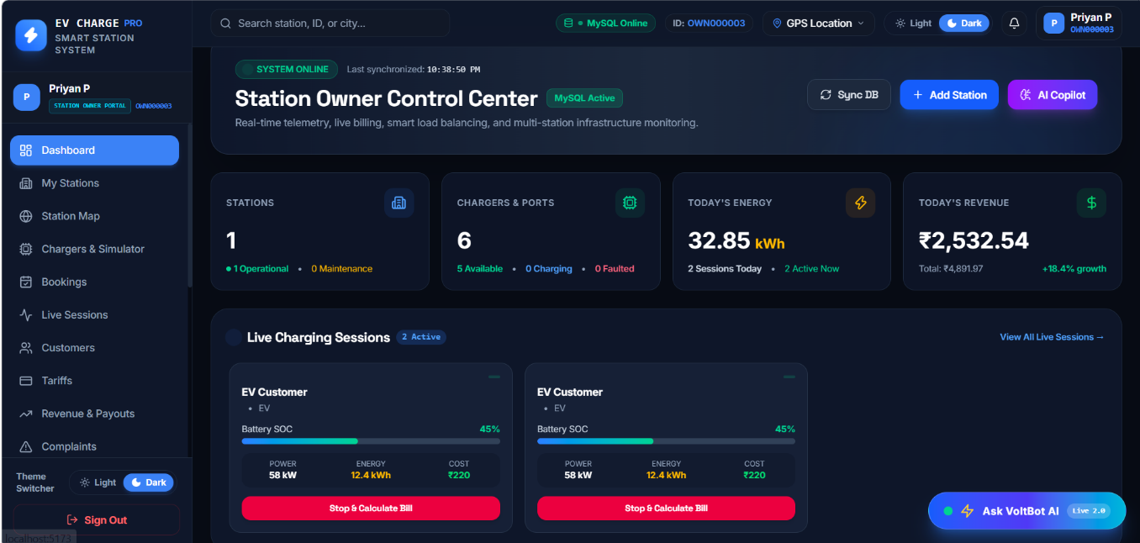
Screenshots / Figures

Fig 8.18 – Station Owner Dashboard – Displaying Station Operations and Charging Activities.
The Station Owner Control Center provides an overview of station operations, charger availability, energy consumption, and daily revenue. It allows station owners to monitor live charging sessions, manage stations and chargers, synchronize data, and calculate bills for completed charging sessions.
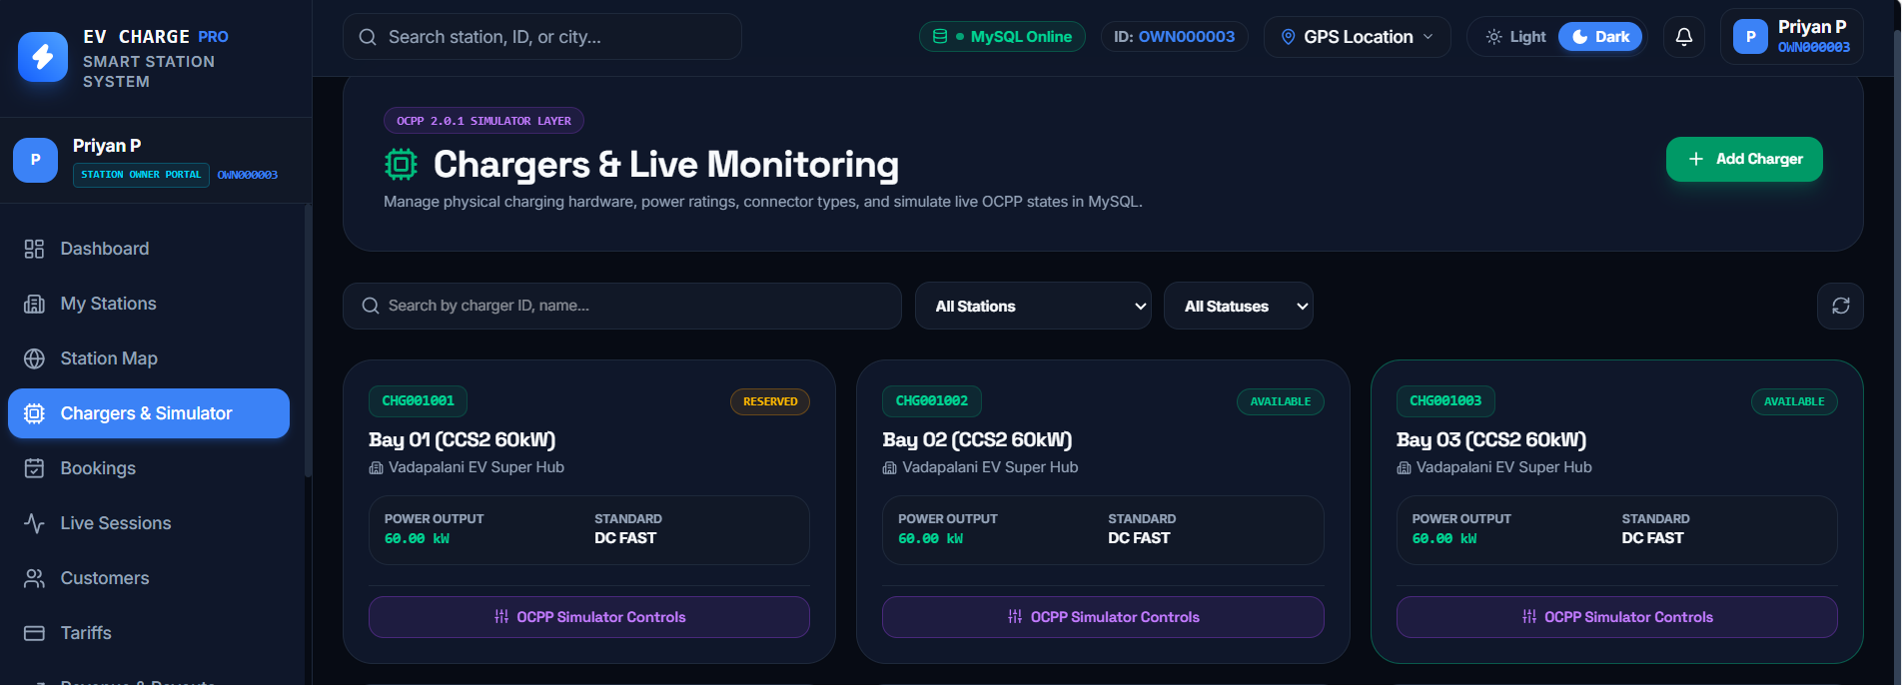

Fig 8.19 – Chargers and Live Monitoring – Displaying Charger Status, Power Output, and OCPP Simulator Controls.
The Chargers and Live Monitoring page allows station owners to add chargers and monitor their availability, power output, and connector standards. It also provides search and filtering options and OCPP simulator controls to manage and simulate charger operating states.
8.9 TARIFF, DYNAMIC PRICING AND SMART RESERVATION
Purpose & Scope
This module manages station tariff plans and reservation intelligence. Tariff configuration supports base, peak, off-peak, connection and idle fees. Smart reservation services provide live status, queues, conflict checking, check-in, no-show and override operations.
Functional Requirements
- Create, update and delete tariff plans for authorized owners/admins.
- Calculate prices using configured charging rates and fees.
- Check charger conflicts before reservation.
- Maintain station queues and queue assignments.
- Support check-in, no-show and manual reservation override operations.
Non-Functional Requirements
- Keep pricing data consistent with the station tariff configuration.
- Prevent conflicting reservations where conflict checks are enabled.
- Record important operational actions in audit logs.
- Allow policy updates only to authorized roles.

Back-of-the-Envelope Estimation
The following values are design-stage estimates for capacity planning. They are not measured production benchmarks.
Parameter | Estimated value | Basis / interpretation
Tariff plans | 1–20 per owner/network | Design-stage configuration estimate
Reservation checks/day | 100–1,000 | Depends on booking traffic
Queue entries/station | 0–50 | Design-stage queue capacity
Pricing response | < 2 seconds target | Design target

Request Flow
- Tariff/reservation UI
- pricing or smartReservation service
- tariffRoutes.js / smartReservationRoutes.js
- Controller/service logic
- Conflict, queue and pricing operations
- MySQL tariffs, bookings and audit logs

API Design
The following representative routes are taken from the supplied Express route files and their server-level /api mounting. Authorization labels summarize the route or middleware context present in the source.
Method | Endpoint | Auth / Role | Request / Parameters | Response | Purpose / Contract
GET | /api/tariffs | Optional auth | Station/filter parameters | Tariff list | Retrieve pricing plans
POST | /api/tariffs | OWNER/ADMIN | Tariff payload | Created tariff | Create tariff plan
PUT | /api/tariffs/:id | OWNER/ADMIN | Tariff update | Updated tariff | Modify tariff plan
POST | /api/chargers/:chargerId/check-conflict | Role-dependent | Booking/time data | Conflict result | Check charger conflict
POST | /api/queue | User/role dependent | Queue entry | Queue record | Join station queue
POST | /api/bookings/:bookingId/override | Authenticated | Override details | Override status | Apply manual booking override

DB Design
Only the principal tables used by this module are listed below. Complete table structures and relationships are retained in Chapters 5 and 6.
Table | Key fields | Relationship | Purpose
tariffs | tariff_id, station_id, base/peak/off-peak rates | References station | Stores pricing rules
bookings | booking_id, tariff_id, times, amount | References tariff | Uses pricing snapshot
audit_logs | action, entity_type, entity_id | Records operations | Supports operational traceability
pricing_rules | Migration-defined pricing fields | Associated with pricing configuration | Supports extended pricing rules

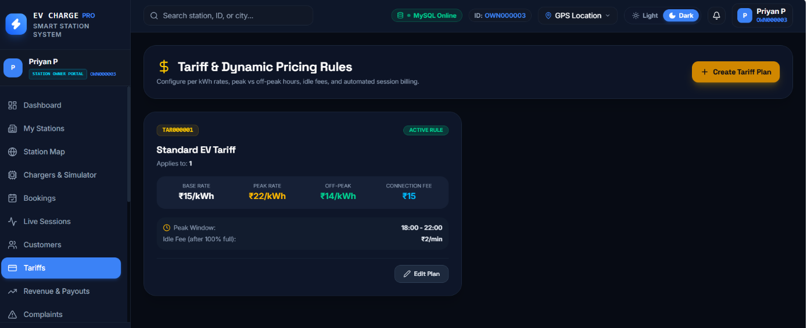
Screenshots / Figures

Fig 8.20 – Tariff and Dynamic Pricing – Displaying charging rates, peak and off-peak pricing connection fees, and idle fee configuration.
The Tariff and Dynamic Pricing page allows station owners to configure charging rates, including base tariffs, peak and off-peak prices, and connection fees. It also displays active pricing rules and provides options to create, edit, and manage tariff plans.
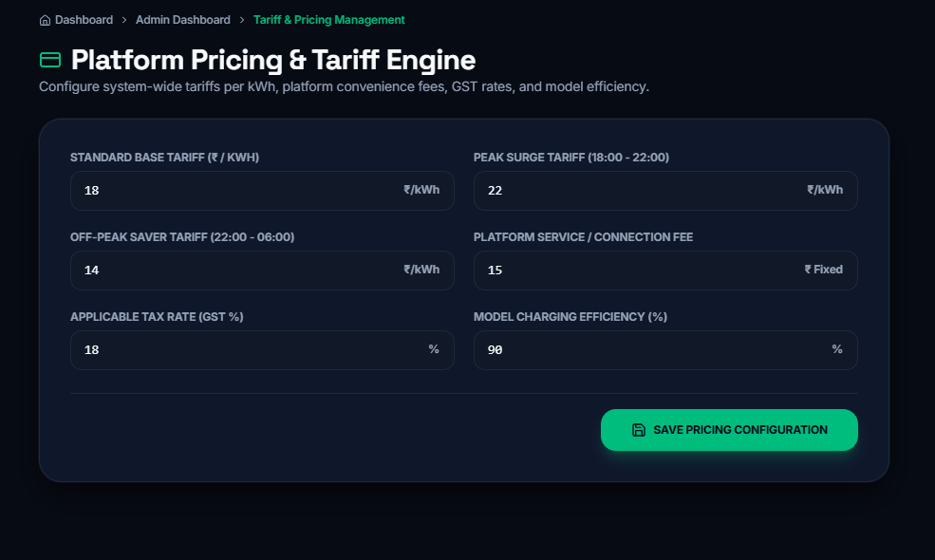
Fig. 8.21 – Platform Pricing and Tariff Management Configuration
The Platform Pricing and Tariff Engine allows administrators to configure standard, peak, and off-peak charging rates, along with platform fees and GST. It also supports setting charging efficiency parameters and saving the pricing configuration for consistent billing across the EV charging network.
8.10 COMPLAINT AND EMERGENCY MANAGEMENT
Purpose & Scope
This module provides a mechanism for customers and station operators to report charging-related complaints and emergency assistance needs. Complaints can be tracked by priority and status, while notifications and audit information support follow-up.
Functional Requirements
- Create and view complaints.
- Update complaint information and status.
- Track complaint priority from low to critical.
- Provide emergency assistance interface and supporting backend service.
- Maintain notifications and audit records for relevant actions.
Non-Functional Requirements
- Keep complaint records associated with users and stations.
- Provide controlled access to complaint updates.
- Maintain traceability of status changes.
- Return clear status responses for customer-facing operations.

Back-of-the-Envelope Estimation
The following values are design-stage estimates for capacity planning. They are not measured production benchmarks.
Parameter | Estimated value | Basis / interpretation
Complaints/day | 10–100 | Design-stage estimate
Open cases/station | 0–50 | Design-stage operational range
Notification events/day | 10–200 | Depends on complaint/emergency activity
Target response | < 2 seconds | Design target

Low-Level Architecture
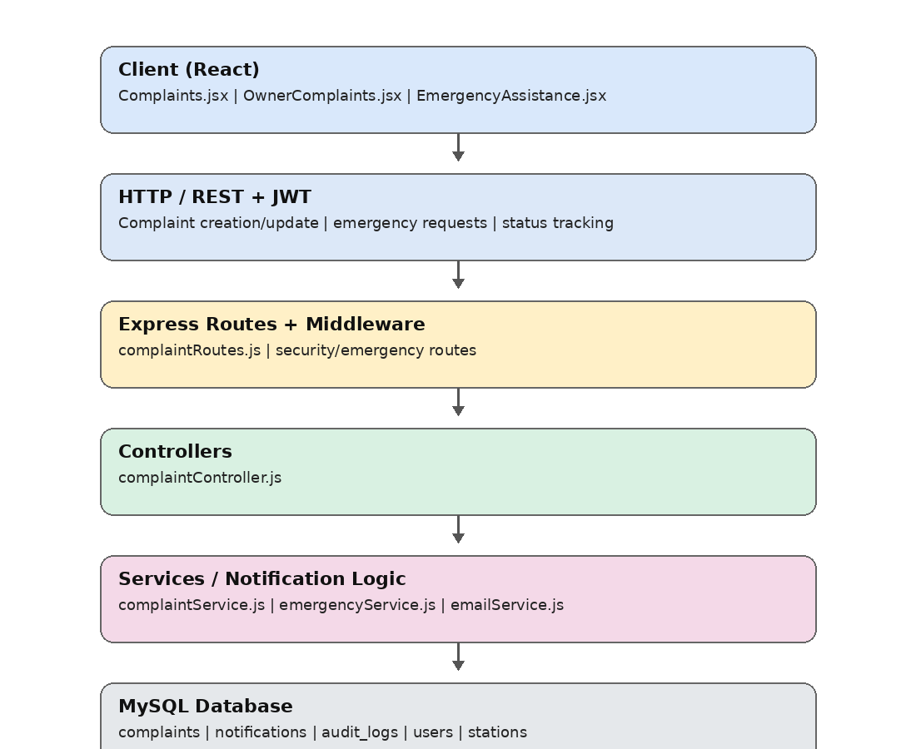
Low-Level Architecture – 8.10.A Complaint And Emergency Management

Request Flow
1. Complaint/Emergency page
2. complaintService.js / emergencyService.js
3. Express complaint/emergency routes
4. complaintController.js / emergency service
5. Notification/email processing
6. MySQL complaints, notifications and audit logs

API Design
The following representative routes are taken from the supplied Express route files and their server-level /api mounting. Authorization labels summarize the route or middleware context present in the source.
Method | Endpoint | Auth / Role | Request / Parameters | Response | Purpose / Contract
GET | /api/complaints | Authenticated/role dependent | Filters/status | Complaint list | Retrieve complaints
GET | /api/complaints/:id | Authenticated/role dependent | Complaint ID | Complaint details | Retrieve one complaint
POST | /api/complaints | Authenticated | Complaint data | Created complaint | Submit complaint
PUT | /api/complaints/:id | Authenticated/role dependent | Complaint update | Updated complaint | Update complaint
PUT | /api/complaints/:id/status | Authorized | Status/resolution | Updated status | Change complaint status
GET | /api/notifications | Authenticated | User context | Notification list | Retrieve notifications

DB Design
Only the principal tables used by this module are listed below. Complete table structures and relationships are retained in Chapters 5 and 6.
Table | Key fields | Relationship | Purpose
complaints | complaint_code, user_id, station_id, priority, status | References user/station | Stores complaint lifecycle
notifications | notification_id, user_id, type, message | References user | Stores system notifications
audit_logs | user_id, action, entity_type, entity_id | Records changes | Maintains traceability
users | user_id, role, contact | Complaint reporter/handler | Associates complaint participants

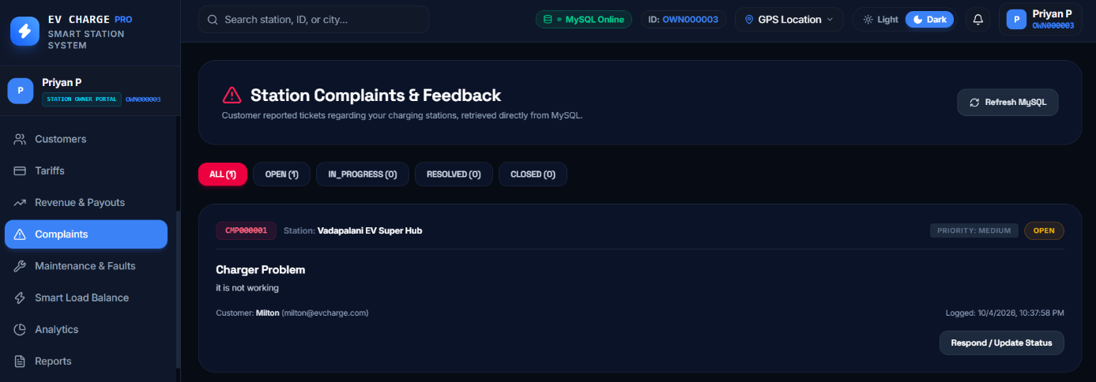
Screenshots / Figures

Fig 8.22– Station Complaints and Feedback Management

The Station Complaints and Feedback page allows station owners to view customer-reported issues, including charger problems, and filter complaints by status. It also enables owners to review complaint details, identify priorities, and respond to customers or update the complaint status.
8.11 ADMINISTRATOR AND TECHNICIAN MANAGEMENT
Purpose & Scope
This module covers platform-level administration and field technician coordination. Administrators manage users, owners, stations, chargers, bookings, payments and approvals, while technicians receive maintenance tasks and update work progress.
Functional Requirements
- View and manage customers and users.
- Approve, reject and suspend station owners and stations.
- Manage chargers, bookings, payments and maintenance records.
- Create and manage technicians.
- Support technician work orders, tasks, faults, maintenance and service reports.
Non-Functional Requirements
- Restrict platform administration to the administrator role.
- Maintain auditable administrative changes.
- Support clear technician workload and status information.
- Keep maintenance records associated with stations, chargers and technicians.

Back-of-the-Envelope Estimation
The following values are design-stage estimates for capacity planning. They are not measured production benchmarks.
Parameter | Estimated value | Basis / interpretation
Managed users | 100–5,000 | Design-stage platform estimate
Stations | 10–500 | Design-stage network estimate
Technicians | 5–100 | Design-stage maintenance estimate
Admin operations/day | 50–500 | Expected management activity

Request Flow
- Admin/Technician React page
- adminService.js / technicianService.js
- adminRoutes.js / technicianRoutes.js
- Controllers
- Management and maintenance logic
- MySQL users, stations, maintenance and audit data

API Design
The following representative routes are taken from the supplied Express route files and their server-level /api mounting. Authorization labels summarize the route or middleware context present in the source.
Method | Endpoint | Auth / Role | Request / Parameters | Response | Purpose / Contract
GET | /api/admin/stats | ADMIN | JWT + ADMIN | Dashboard statistics | Retrieve platform metrics
GET | /api/admin/users | ADMIN | JWT + ADMIN | User list | List platform users
PUT | /api/admin/owners/:id/approve | ADMIN | JWT + ADMIN | Owner ID | Approve owner
PUT | /api/admin/stations/:id/approve | ADMIN | JWT + ADMIN | Station ID | Approve station
POST | /api/technicians/work-orders | Technician context | Work-order data | Created work order | Create maintenance work order
PUT | /api/technicians/work-orders/:id | Technician context | Work-order update | Updated work order | Update maintenance work order

DB Design
Only the principal tables used by this module are listed below. Complete table structures and relationships are retained in Chapters 5 and 6.
Table | Key fields | Relationship | Purpose
users | user_id, role, status | Base identity | Stores platform users
station_owners | owner/user and business fields | References users | Stores owner records
maintenance_tickets | ticket_id, station_id, charger_id, technician_id | Asset/technician links | Tracks maintenance
audit_logs | user_id, action, entity_type, entity_id | Administrative trace | Records important changes

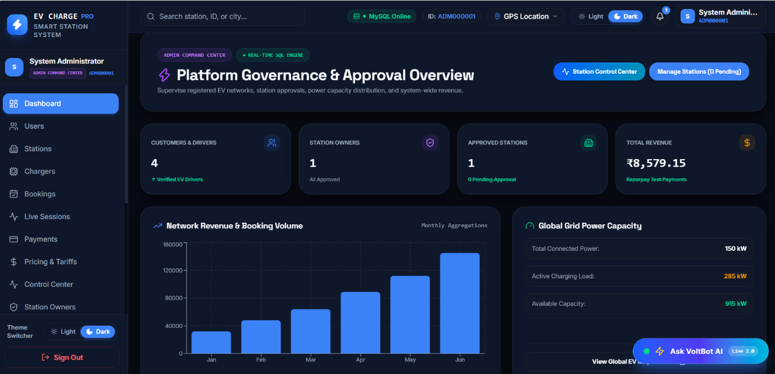
Screenshots / Figures

Fig 8.23– ADMIN DASHBOARD
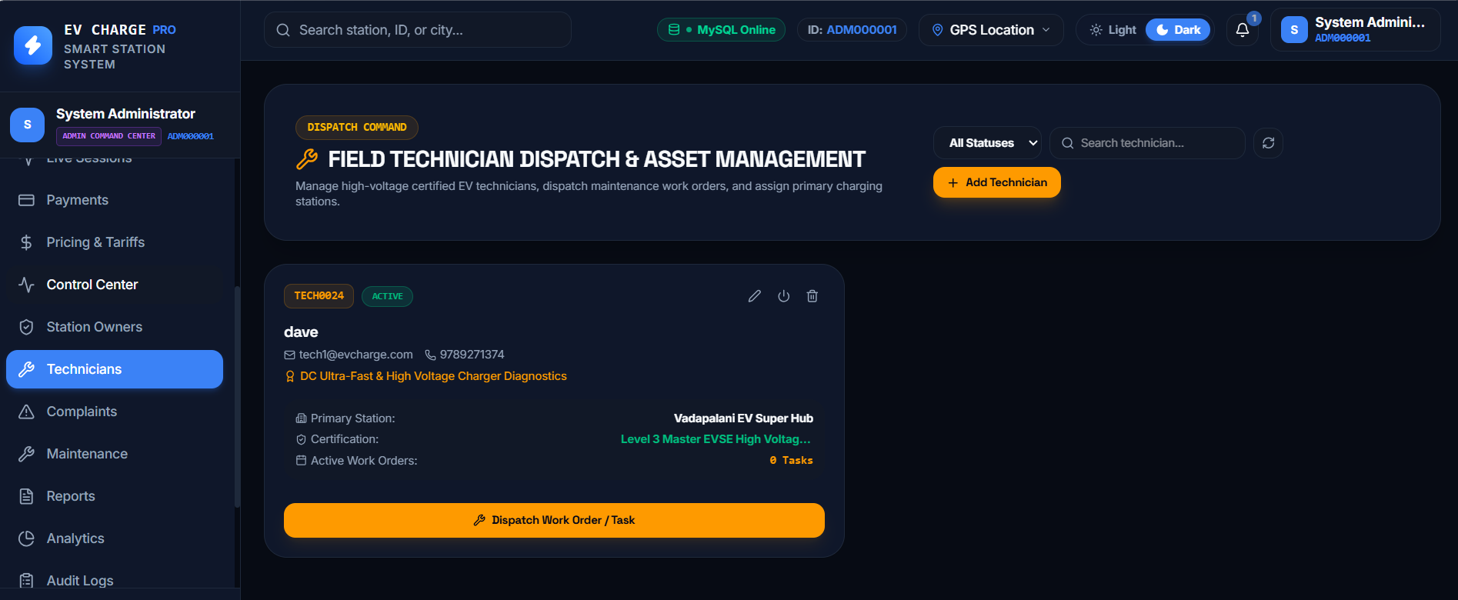
The Admin Dashboard provides a centralized overview of customers, station owners, approved stations, platform revenue, and charging network capacity. It enables administrators to monitor booking and revenue trends, manage station approvals, and access the Station Control Center for system-wide operations

Fig 8.24 – FIELD TECHINICIAN DISPATCH AND ASSET MANAGEMENT
The Field Technician Dispatch and Asset Management page allows administrators to manage technician profiles, monitor availability, and view certifications and assigned charging stations. It also supports adding technicians and dispatching maintenance work orders or tasks for EV charging infrastructure.
8.12 STATION CONTROL CENTER AND REAL-TIME OPERATIONS
Purpose & Scope
The Station Control Center combines live charger state, reservations, queues, check-in, no-show handling, offline walk-ins, conflict detection and audit information into one operational view for station operators.
Functional Requirements
- Display charger states such as available, reserved, protected, charging, occupied and maintenance.
- Monitor upcoming reservations and active charging sessions.
- Support offline walk-ins and reservation check-in operations.
- Manage queues and assign queue entries.
- Detect conflicts and record operational audit events.
Non-Functional Requirements
- Provide near real-time operational information.
- Prevent inconsistent charger and reservation states where conflict controls are applied.
- Maintain auditability of manual overrides and operational actions.
- Support synchronization between booking, charging and charger status.

Back-of-the-Envelope Estimation
The following values are design-stage estimates for capacity planning. They are not measured production benchmarks.
Parameter | Estimated value | Basis / interpretation
Chargers monitored | 10–500 | Design-stage network range
Queue entries/station | 0–50 | Design-stage operational range
Live updates | Near real-time | Socket.IO based
Operational records/day | 100–1,000 | Design-stage estimate

Request Flow
- StationControlCenter.jsx
- ownerControlCenterService.js / smartReservationService.js
- smartReservationRoutes.js / ownerRoutes.js
- Controllers and conflict logic
- Socket.IO live events + MySQL state
- Updated charger grid and operational status

API Design
The following representative routes are taken from the supplied Express route files and their server-level /api mounting. Authorization labels summarize the route or middleware context present in the source.
Method | Endpoint | Auth / Role | Request / Parameters | Response | Purpose / Contract
GET | /api/owner/control-center | OWNER/ADMIN | JWT + role | Control-center snapshot | Retrieve station operations
GET | /api/stations/:stationId/live-status | Role-dependent | Station ID | Live charger status | Retrieve live station state
GET | /api/queue/:stationId | User/role dependent | Station ID | Queue entries | Retrieve station queue
POST | /api/queue | User/role dependent | Queue data | Queue entry | Join station queue
POST | /api/bookings/:bookingId/check-in | Authenticated | Booking ID | Check-in result | Check in reservation
POST | /api/bookings/:bookingId/no-show | Authenticated | Booking ID | No-show status | Mark reservation no-show

DB Design
Only the principal tables used by this module are listed below. Complete table structures and relationships are retained in Chapters 5 and 6.
Table | Key fields | Relationship | Purpose
chargers | charger_id, station_id, status, online_status | References station | Current charger state
bookings | booking_id, charger_id, status, times | References charger | Reservation state
charging_sessions | session_id, charger_id, start/end, energy | References charger | Active charging state
audit_logs | action, entity_type, entity_id | Operational trace | Stores control-center actions

Screenshots / Figures
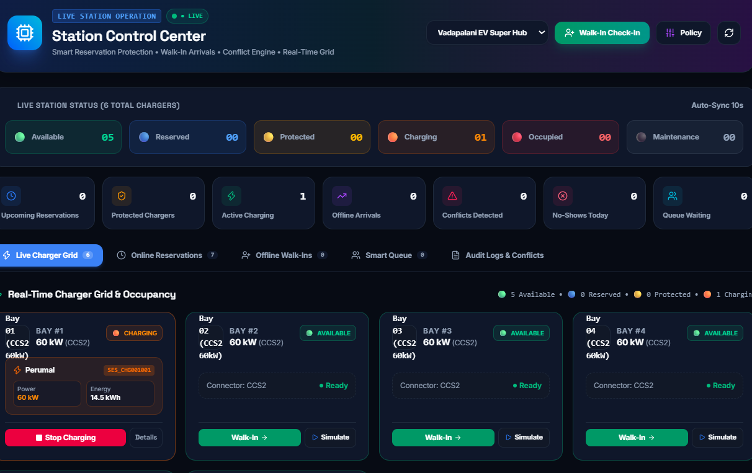

Fig 8.25 – Real-Time Charger Grid and Occupancy
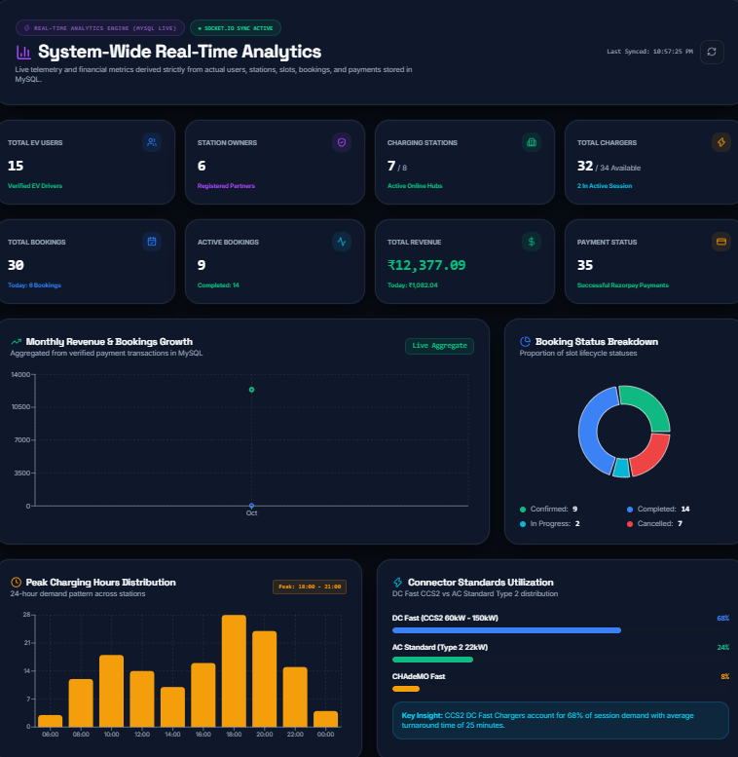
The Station Control Center provides real-time monitoring of charger availability, reservations, active charging sessions, offline arrivals, conflicts, and waiting queues. It enables station operators to manage walk-in check-ins, monitor individual charger status, and coordinate charging operations efficiently.

Fig. 8.26 – System-Wide Real-Time Analytics Dashboard
The System-Wide Real-Time Analytics dashboard presents key metrics such as total users, station owners, charging stations, bookings, revenue, and payment status. It also visualizes monthly revenue trends, booking status distribution, peak charging hours, and connector utilization to support data-driven operational decisions.

CHAPTER 9 CONCLUSION
In conclusion, the EV Charging Station Management System provides a comprehensive and efficient solution for managing electric vehicle charging activities in a digital environment. It reduces manual work and simplifies important operations such as vehicle registration, charging station discovery, slot booking, charging session management, and payment processing. The system provides users with an organized platform to access charging services conveniently.
The system also supports station owners and administrators in managing charging infrastructure effectively. Features such as real-time charger monitoring, station control, tariff management, revenue tracking, complaint handling, technician management, and maintenance coordination help improve operational efficiency. Role-based access ensures that customers, station owners, technicians, and administrators can perform their respective activities securely.
Overall, the system creates a connected environment between EV users, charging station owners, technicians, and administrators. The integration of database management, payment processing, charging simulation, booking management, and monitoring features makes the platform suitable for practical EV charging operations. It improves user convenience, supports better resource management, and provides a centralized approach for managing the complete EV charging ecosystem.

